Bluetooth Smartwatch Manual
Thank you for choosing smartwatch of our company. You can get a thorough and comprehensive understanding on use of the watch and appreciate its practical functions and simple operation method by reading this Manual.
Mainly used for adaptation of brand smartphone, the smartwatch can synchronize telephone book in smartphone and provides various practical functions and services so that you can operate smartphone during work and at leisure time.
The company reserves the right to modify contents in the Manual without any notice in advance.
IPHONE USER:
When you get the watch, you can install “smartblue” application program in iphone terminal first so as to achieve instant message display and reminding, such as short message, WhatsApp and Facebook and so on.
“Smartblue” APP acquisition method of Iphone: search “Smartblue” in APP store directly for downloading.
After “smartblue” is installed in Iphone, activate and open Bluetooth function in “Bluetooth settings” in “Bluetooth” menu of the watch, open the Bluetooth in “Settings” on iphone and then pair and connect with watch after device name is searched (device name of watch can be found in “My name” in “Bluetooth” menu). After completion, open “smartblue”, click “Register” and fill in related data to log in main interface. There are three icons at the bottom of main interface. Click the “Bluetooth” icon to enter into “Bluetooth” interface and then device name of the watch will be searched. Click the device name and then pair and connect. After completion, watch can be used for answering phone and dialing telephone number and for instant message prompt.
Andriod mobile phone user:
When you get the watch, you can install “Smartwatch.apk” application program in Android smartphone so as to realize instant message display and prompt, such as short message, WeChat and QQ.
”Smartwatch.apk“ acquisition method of Andriod mobile phone:
APK acquisition method 1: scan the following two-dimension code for downloading by two-dimensional scanner of smartphone

APK acquisition method 2: enter the following website via computer or mobile browser for downloading
Website: www.myuwatch.com/Smart-Watch.apk
After “Smartwatch.apk” is installed in smartphone, login interface will prop up after “SmartWatch” is opened in phone; click for registration and then prompt of “Enable Accessibility” will prop up when entering into main interface after filling in related information (such as phone number and password); tick at “Next time don’t show” and enter into “Accessibility” interface after clicking “OK”; find SmartWatch and open, then return back to APK main interface and enter into phone Bluetooth interface after clicking “Unbound” at the top right corner; open the Bluetooth and then activate and open Bluetooth function of phone in Bluetooth setting in Bluetooth menu of watch; phone initiates connection after searching device name of watch (device name of watch can be found in “My name” in “Bluetooth” menu); then smartphone will send “Bluetooth pairing request”; select “Pair”; after successful pairing, Watch will remind “**connected”, at the same time of which a “ ” icon will appear at the home screen, showing that watch has been successfully connected with your smartphone; after successful connection, you can enjoy function in watch.
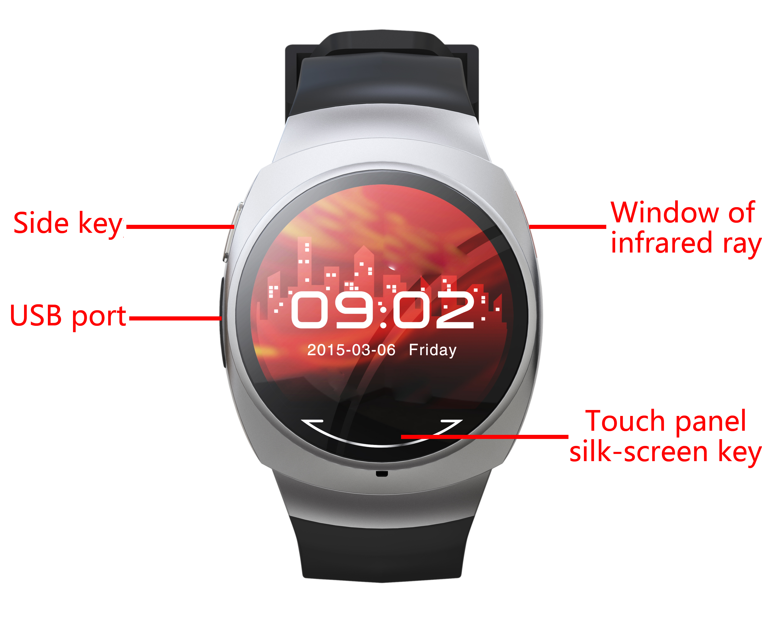
※ Operation Instructions for the Watch
Side key: long press is for startup and shutdown, while short press is for returning back to standby interface)
Touch panel silk-screen key: enter key
Touch panel gesture action: return by sliding from left to right; confirm by sliding from right to left
Touch panel: confirm by clicking screen
※ Introduction to main menu: major functions of watch are displayed in 3 pages in total.

First page: Bluetooth, ,Call log, Dialer, Notifier, Remote camera, Stopwatch, BT Music, Messaging, Phonebook;
Second page: TimeDate, Anti lost, Ringtone, Pedometer, Ecompass,Clocktype, Settings, Sleep monitor, Powersave;
Third page:Alarm, Sedentary reminder, Findhone, Remote Controller,Language

Function information:
● Bluetooth：The following menus can been seen by opening this function.
1）BT sync～Peripheral Bluetooth devices can be searched and pairing connection can be initiated.
2）Bluetooth setting～Bluetooth can be opened, device can be closed and device name of the phone can be displayed.
● Call log：The following menu will be seen after opening this function.
1）Missed calls～Display missed calls in phone and dialing the corresponding linkman can be made at the same time.
2）Dialled calls～Display dialed calls in phone and dialing the corresponding linkman can be made at the same time.
3）Received calls～Display received calls in phone and dialing the corresponding linkman can be made at the same time.
4）All calls～Display all calls in call records of the phone.
● Dialer：Dialing can be made after watch and phone are connected. Input number and then click the silk-screen key on bottom of touch panel to dial.
● Notifier： Such instant messages as QQ/WeChat can be checked. This function can be used only after “Smartwatch.apk” is installed in Android phones, while Iphone should be installed with “smartblue”.
●Remote camera: Phone camera can be opened/closed remotely to complete photo taking via pressing enter key. (This function can be realized only “Smartwatch.apk” is installed in Android phones and screen of phone is not locked. (This function is not supported by Iphone currently)
●Stopwatch：Time can be reckoned after opening this function.
●BT Music： Control play of music in phone.
● Messaging：The following menu can be seen after opening this function. This function can be used only after the phone is installed with “Smartwatch.apk” application program. (This function is not supported by Iphone currently)
1）Inbox～Display short messages in phone.
2）Outbox～Display short messages in phone that have been sent.
● Phonebook：Linkmen in the phone will be displayed after watch and phone are connected (1,000 can be displayed).
●TimeDate: You can set the time and date on watch, open this function will see the following menu
1）Set Time ~ Can set up time
2）Set Date ~ Can set up date
3）Time Format ~12 or 24
● Anti lost：After opening, watch will make alarming sound after watch is a certain distance away from phone.
1)Enable
2)Disable
● Ringtone：Different states of ring tone can be set. The following options can be seen after opening this function.
1）Mute
2）Vibration
3）Ring1
4）Ring2
5）Ring3
●Pedometer：Travelling time (hour, minute, second) and mileage (km) can be calculated. The following menu can be seen after opening this function. (Step-counting data can be synchronized to phone after Android phone is installed with “Smartwatch.apk” ;Step-counting data synchronized is not supported by Iphone currently)
1）Pedometer ～After entering into the menu, press software on the right for triggering and begin to calculate step frequency, total mileage (km) and calorie (kcal).
2）Step Setting～Set step distance according to height proportion.
3）Weight Setting～ Set according to height.
4）Clear History ～ Eliminate history records.
●Ecompass：Move and calibrate according to the displayed direction of screen after opening. This function can be used only after calibration. Red pointer Which is on the ecompass interface point to “North” .
●Clocktype: Open this function will see the following menu
1）Analog1
2）digital1
● Settings： The following functions can be seen after opening this function.
1）LCD backlight～Backlight standby time can be selected.
2）Units Setup～Metric unit and British unit can be set.
3）About Watch～Display phone software version information.
●Sleep monitor：Sleep quality can be monitored after opening this function. (Sleep data can be synchronized to phone after Android phone is installed with “Smartwatch.apk”.Sleep data synchronized is not supported by Iphone currently)
1）SleepSwitch～ Open or close
2）Sleep monitor～ Display sleep data
3）Clear data～ Click here and all data can be eliminated.
●Powersave: Open this function will see the following menu
1) ON ~After choice ON, the brightness dimmed, the power-saving mode
2 ) Off ~After choice OFF, the brightness of light, enter the state of daily power consumption
●Alarm：Four alarms can be defined by users.
●Sedentary reminder: You can choose to turn this feature on or close to sedentary reminder and can set how long a reminder
●Find phone: click it to find the phone connected, This function needs to install the " Smartwatch.apk" application for use in mobile phone terminal.Find phone is not supported by Iphone currently.
●Remote Controller: remote control for the TV or other equipment by the watch, open this function will see the following menu
1)Television ~ After the completion of setting button, you can remote control switch, volume addition and subtraction, channel switching by the watch
2)Other ~ After the completion of setting button, you can remote control some equipment
3)Reset ~You can reset the buttons
The method of setting button:It have to aim the remote control of equipment at the infrared window of the watch while setting button.There a button flashing red color at the interface is the currently set button(the unset buttons are display gray color) .After press a any function key of the remote control of equipment, the watch will shake,and the button which flashing red color will turn to green color. It meat that this button’s setting has completed.Follow the method above,and complete other gray button’s setting.when all the button of the interface turn to green color, the setting button is completion.
●Language：Watch language can be set.

Tip: This product's battery is non-removable. And maybe the product can't power on when it is idle for more than a month on account of the wastage of itself. Please charge your device.

