Fire Micro FPV Brief Instruction

Features:

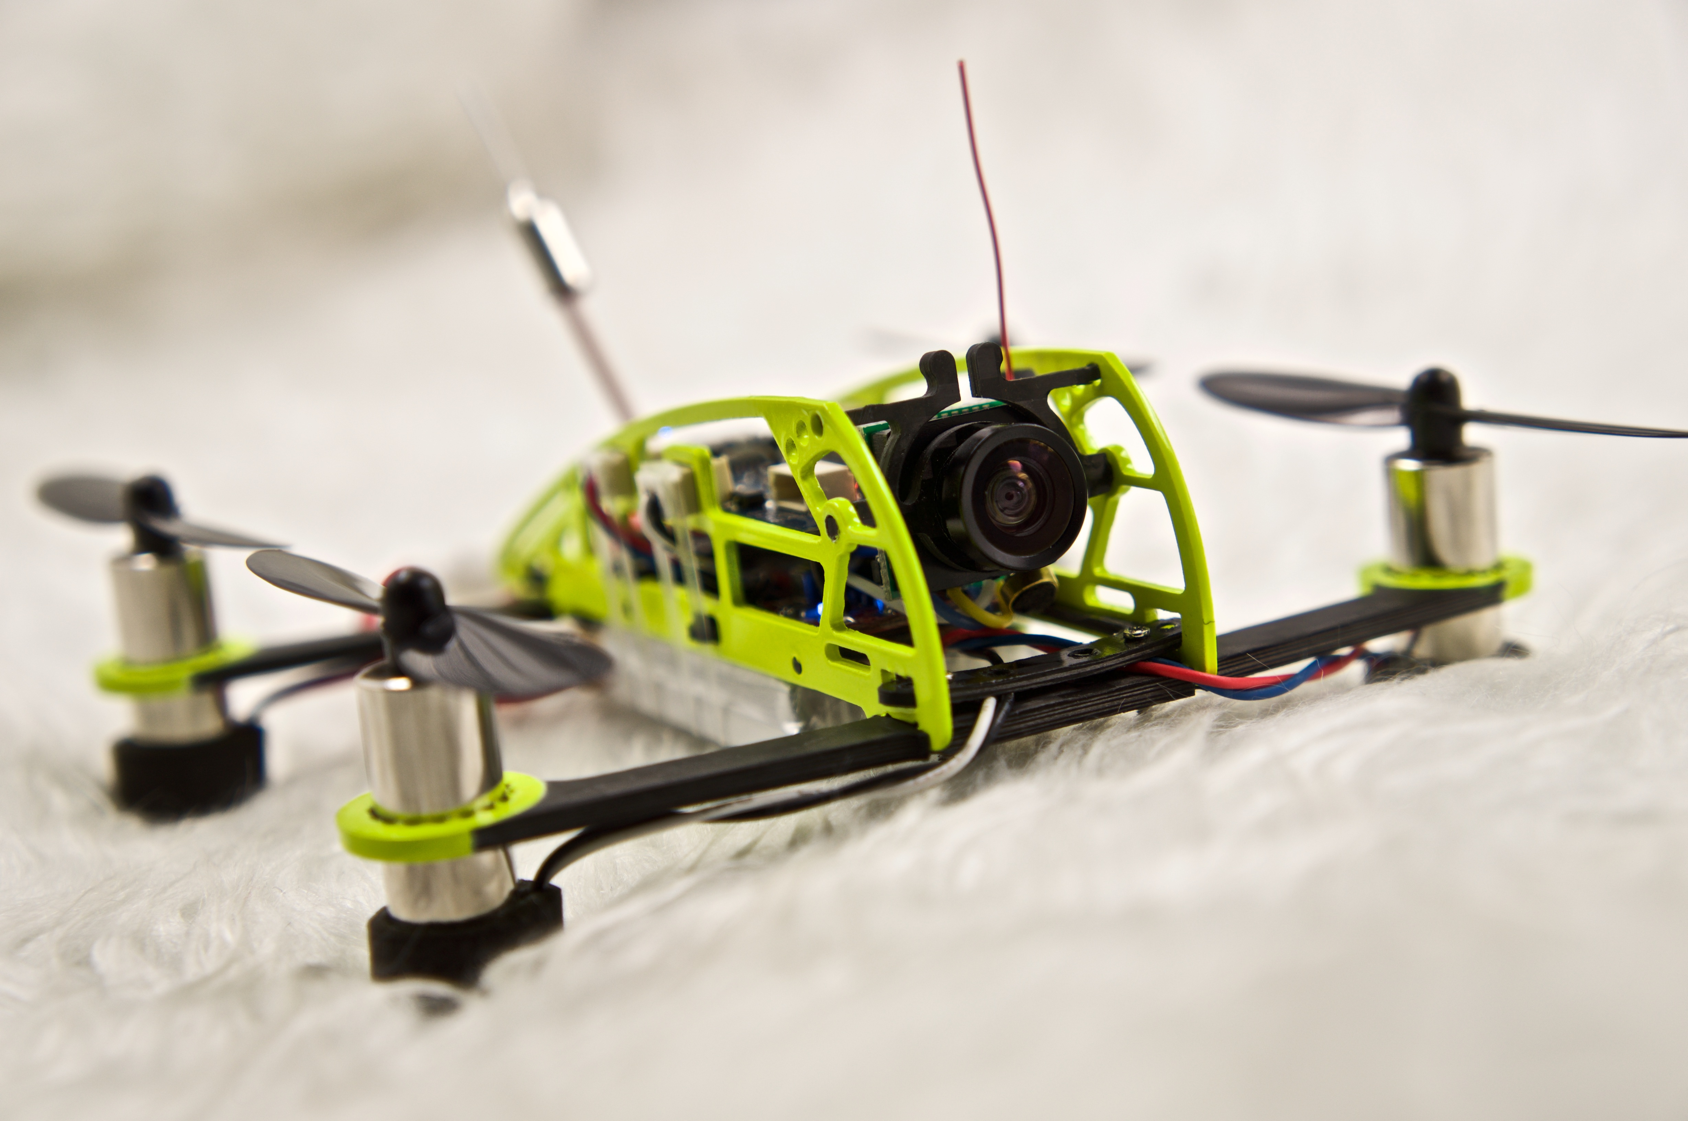

* The frame is high quality carbon made, which gets super light, strong, durable and crash resistance features.
* It comes equipped with 720X576 camera that can shoot videos from three angles 5°, 25° and 45° adjustable according to different flight circumstance and flight speed.
* Comes completely assembled, with a lipo battery and USB charge cord included.
* All of the parts are available and are on sale, so it is easy and fast for repairing and changing damaged parts, fully enjoy worry-free flight indoors or out.
* Super-light design increases its utmost power and last its flight time.
* Binding and then flying
* Open source NAZE32 cleanflight flight control board, customers can adjust parameters according their own flight habits.
* Small, powerful, no matter indoors flying or outdoor flying, you can enjoy flight freely.Still as a virgin, flying like a running rabbit.
* Portable, you can take it to everywhere such as a model party, a vocation for fun flight.

Basic parameters:

* Distance between diagonal motors: 104mm
* Weight: 37g (not including battery)
* Motor: brushed 8520 motor(super powerful custom made)
* Speed control: built-in brushed ESC
* Flight control board: NAZE32 (open firmware CleanFlight or BaseFlight)
* Propeller: 55mm
* Built-in recever: DSM2 compatible 7CH receiver
* Video Transmitter: 5.8G 16CH 200mw
* VTX range: 500m~800m
* Transmitter range: it depends on the output power of your transmitter
* Camera: 650TVL 170° 720X576 pixel
* Battery: 3.7V 700mAh 25C
* Flight time: about 8 miniutes

**Package included:**

* Assembled Fire micro FPV quadcopter 1 set
* Battery 700mAh 3.7V 25C 1 piece
* Propellers:　8 pcs(4 CCW, 4 CW)
* Charger cord: 1 set

Brief description:

Fire Micro FPV quadcopter is a super small size but highly integrated quadcopter, it gets DSM2 compatible receiver and FPV 5.8g video transmitter system. Most of the assembly and adjustment has been finished, and is flashed the latest CleanFlight firmware. The only thing customer needs to do is to binding and unlocking, and calibrate channels of your transmitter, set up reverse or normal direction and travel adjustment and flight mode, and then go and fly! Customers can change parameters on FC according to their own flight habit and special hand control feeling, upgrade the latest CleanFlight firmware any time.

Receiver binding:

1, Connect the battery, red LED flashes slowly

2, After 10 seconds, red LED flashes quickly and enters binding mode.

3, Turn on the transmitter and starts its binding mode, it indicates binding successfully when the red LED light comes to bright constantly.

Note: the above steps are for the first time use, after that, for normal use, you only need to turn on the transmitter first and then connect FC with power.

Meaning of the state of the red LED

* Red LED flashing quickly indicates binding mode.
* Red LED flashing slowly indicates no signal communication from transmitter
* Red LED coming to bright constantly indicates binding with transmitter

Propeller mounting:



Parameter adjustment:

1, Download CleanFlight software

* download google browser
* Search “CleanFlight” in “application” of Google browser, and install it
* Install USB driver

2, Set up basic parameters



3, Parameters adjustment on transmitter:



Configure channels on Channel Map of CleanFlight accordingly.

Normal or reverse channel adjustment

normal or reverse direction of the channel on transmitter can be adjusted through the following operation:

* Pull throttle up, the progress bar will be to right
* Pull pitch stick up, the progress bar will be to right
* Pull Roll stick to right, the progress bar will be to right
* Pull Yaw stick to right, the progress bar will be to right

Travel range adjustment: each channel can be adjusted by transmitter to 1500(mid), min< or =1000, max > or = 2000.

Flight mode: flight mode can be set through CH5 on transmitter, CH5 corresponds AUX1.



Note: No selection for any flight mode means manual flight mode, a value of AUX1 more than 1700 means manual flight mode.

Unlock and flying:

When we finished binding, calibrating channels of transmitter on Cleanflight “Channel Map”, setting normal or reverse direction, travel range and identified flight mode, we can try its maiden flight.

Note: please try to put the antenna of receiver and VTX to upright, in this way, it can maximum its control range and video transfer distance.

* Throttle unlocking: Pull throttle stick to lowest, then to its rightmost position in Yaw way, when the green LED on FC comes to bright constantly, it means unlocking successfully.
* Throttle locking:　Pull throttle stick to lowest, then to its leftmost position in Yaw way, Green LED light is off or flashes, it indicates throttle is locked.

Note: customer can set an idle(not used) channel through CleanFlight as unlocking or locking by using a switch on transmitter.

Firmware upgrading:

Select NAZE (stable) latest version firmware, click Load Firmware [online] upgrading firmware according to tips.

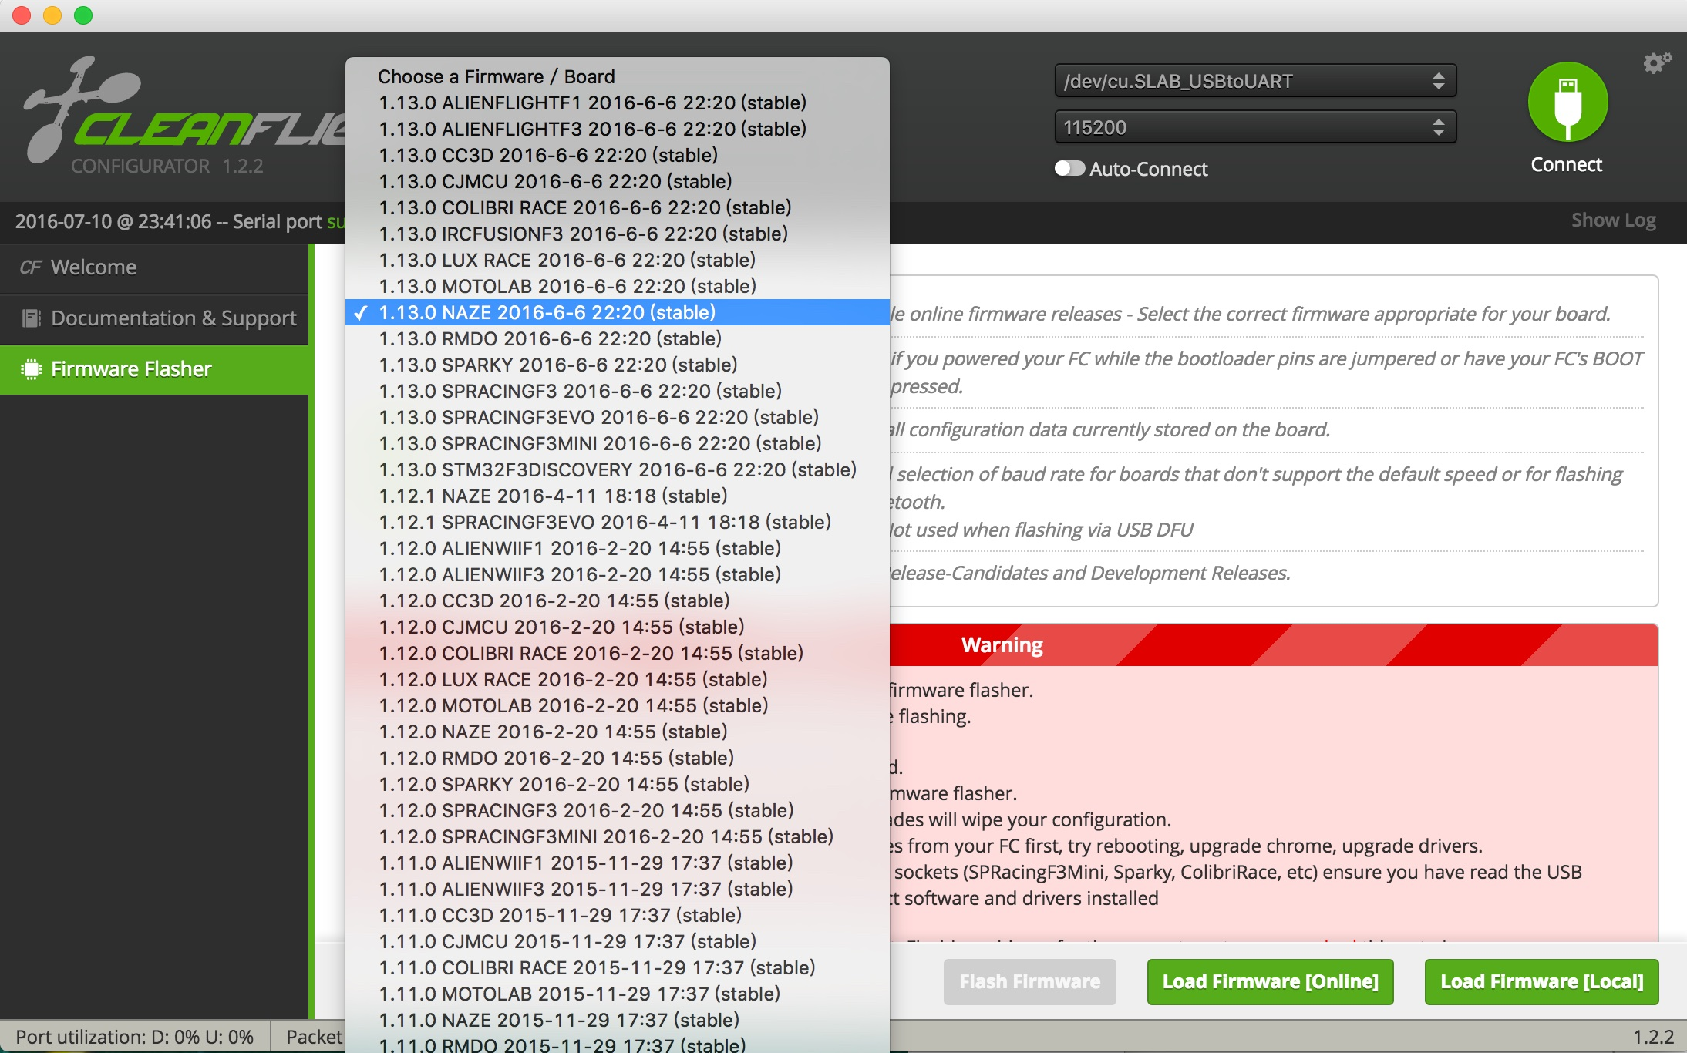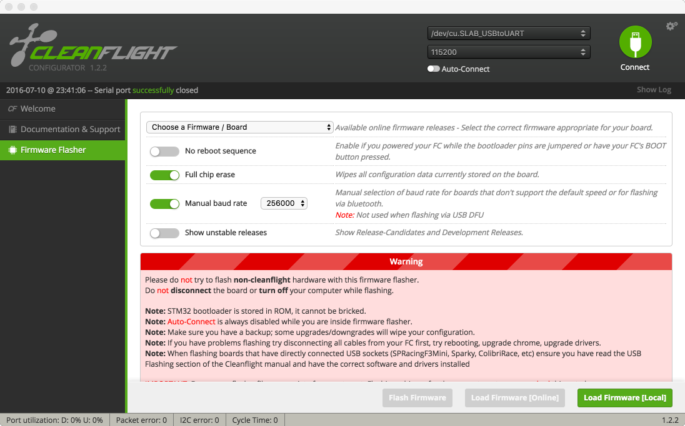

Short connect Boot 0 according to the following picture:

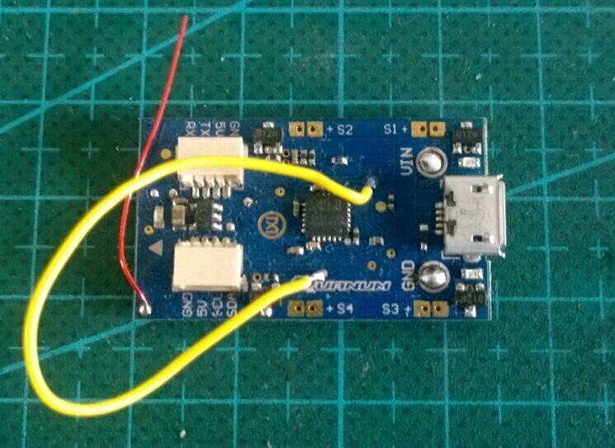

Note: please change output PWM to brushed driving way after firmware upgrading! Please check the following for details



How to change to brushed driving :

please enter the following order

set motor_pwm_rate=4000

save



Video transmitter frequency table for setting up:

| Channel | frequency | SW1 | SW2 | SW3 | SW4 |
| --- | --- | --- | --- | --- | --- |
| E1 | 5705MHz | ON | OFF | ON | ON |
| E2 | 5685MHz | ON | OFF | ON | OFF |
| E3 | 5665MHz | ON | OFF | OFF | ON |
| E4 | 5645MHz | ON | OFF | OFF | OFF |
| E5 | 5885MHz | OFF | OFF | ON | ON |
| E6 | 5905MHz | OFF | OFF | ON | OFF |
| E7 | 5925MHz | OFF | OFF | OFF | ON |
| E8 | 5945MHz | OFF | OFF | OFF | OFF |
| B1 | 5733MHz | ON | ON | ON | ON |
| B2 | 5752MHz | ON | ON | ON | OFF |
| B3 | 5771MHz | ON | ON | OFF | ON |
| B4 | 5790MHz | ON | ON | OFF | OFF |
| B5 | 5809MHz | OFF | ON | ON | ON |
| B6 | 5828MHz | OFF | ON | ON | OFF |
| B7 | 5847MHz | OFF | ON | OFF | ON |
| B8 | 5866MHz | OFF | ON | OFF | OFF |

Details for simple charger:

Input: DC5V 0.5～2A, USB port can connect with a mobile phone charger or a portable external mobile phone charger

　Output: DC3.7V 500mA X4

　Red LED comes to bright constantly when it is on charging

Red LED is off when battery charging is finished.