F3_EVO_BRUSH flight controller integrated RC Receiver for QX90/QX90C/QX95
Dimension: 22mm*32.5mm
Thickness: 1.2mm
Weight: 3g
Integrated receiver option:
Frsky 8CH sbus receiver(D8 mode)
Flysky 6CH PPM Receiver(AFHDS)
DSM2 6CH PPM Receiver
Coreless motor plug: SH1.0
Firmware: SP RACING F3 EVO 1.13.0
Support work voltage: 7.0~8.4v(2S Lipo battery)

Features:
- F3_EVO_Brush revision is out of the F3 EVO SP RACING is based on a SP RACING F3 EVO firmware 32 brush flight control.ler
- Independent design of the circuit structure
- Using STM32F303CCT6 + MPU6500, advanced hardware platform F3 guarantee more stable flight.
- With a large and high quality current NMOS transistors, operating current of up to 10A or more. Each Brushed motor is equipped with freewheeling diodes.
- Integrated 2.4G receiver, there are 3 types receiver option to choose.
- With battery voltage detection and buzzer interface(solder pad)
- LED_STRIP Function(solder pad)
Connection diagram:
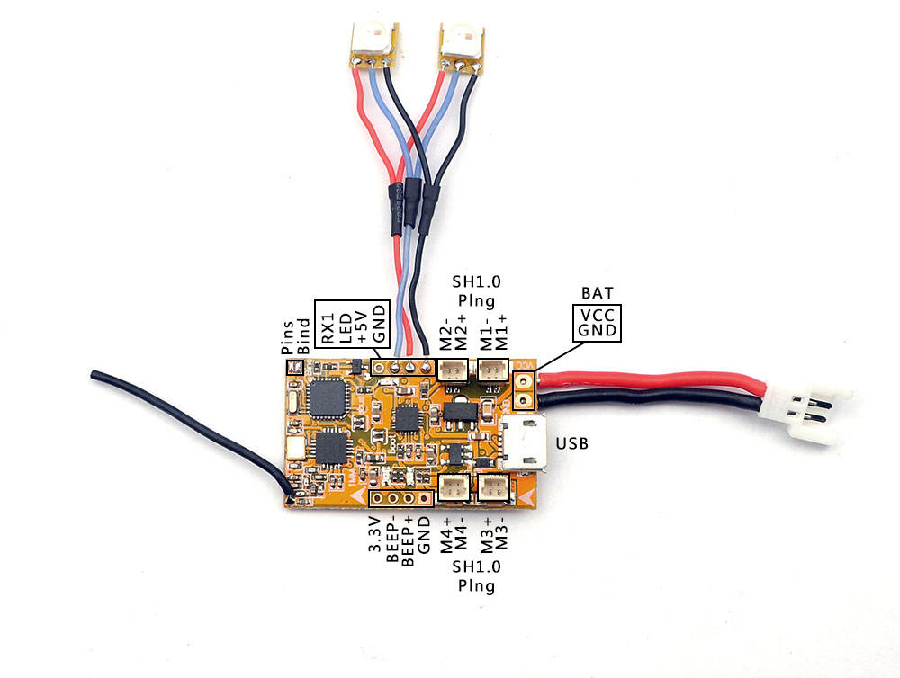
Receiver configuration:
- Frsky receiver option
Enable Seria_RX for UART2 and Set Receiver mode RX_SERIAL ,Select SBUS in Cleanflight or Betaflight configurator.
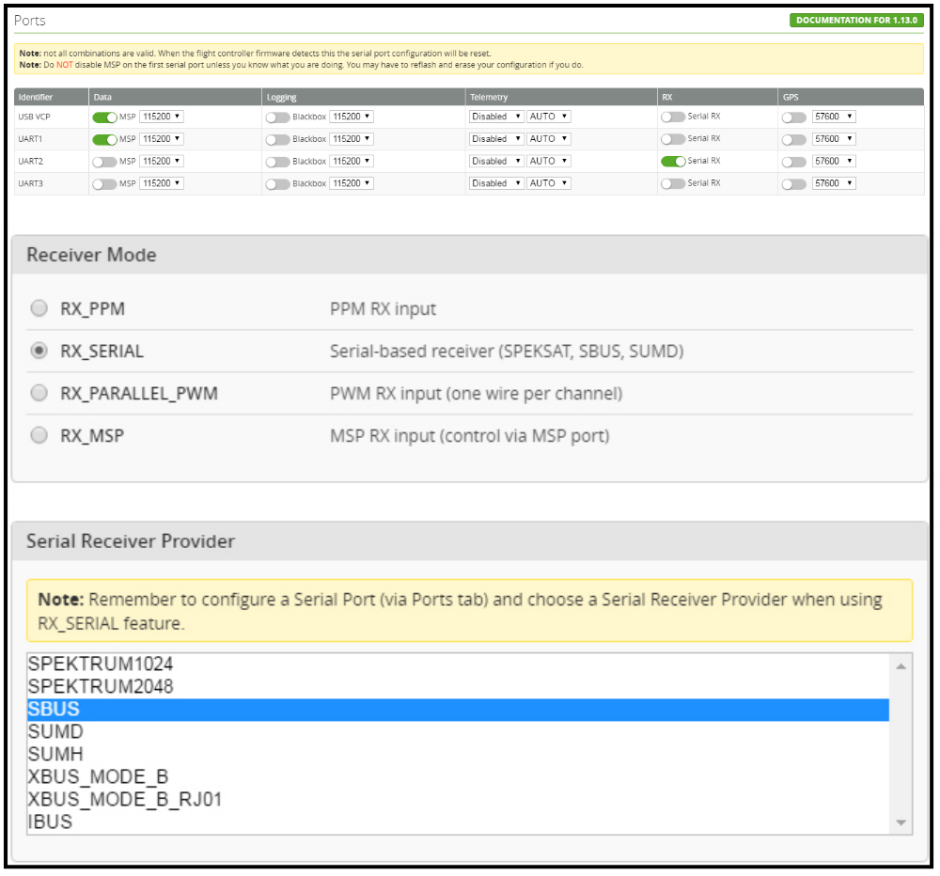Bind procedure:
- Turn on the transmitter , select D8 mode for the Receiver.
- Connect the battery to the board while Jumped the two “BIND” pins on the Board, the green LED will get be solid, this indicates the receiver get into the binding mode.
- Move to the Receiver [Bind] option in the transmitter and ENT to Bind with the receiver, The transmitter beeps.
- The green LED on the board will turning off, this indicates that the bind process was successful. Reconnect the battery for the flight controller, and the green LED on the receiver is solid again. It means connection is established with your transmitter

- Flysky Receiver Option
Just Set Receiver mode to be RX_PPM
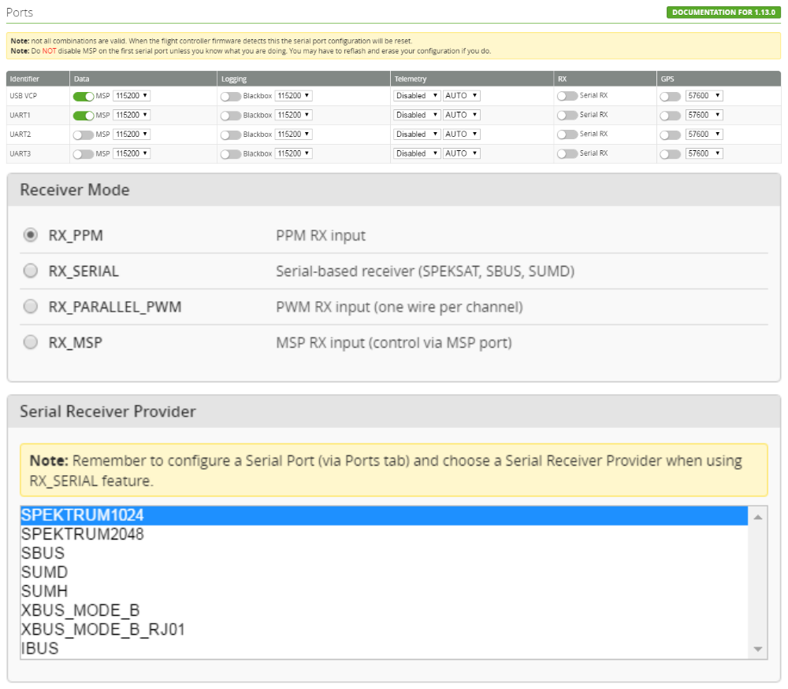

Bind procedure:
- Turn on your radio and Set receiver mode to AFHDS, then get your radio into binding mode.
- Connect the battery to the flight controller while Jumped the two "BIND" Pins on the board ,the Green LED will getting to be solid first and turn off for a second ,then it will getting to be solid again , this indicates binding successfully
- Reconnect the flight controller and the battery ,the Green LED on the board flash fast again, this indicates connection is established with your transmitter.

- DSM2 Receiver Option
Just Set Receiver mode to be RX_PPM and select SPEKTRUM1024

Bind procedure:
This DSM2 version has an "auto-bind" procedure just like with small toy Quadcopter . First Connect the battery to the flight controller, waiting board to get into binding mode . The green LED will blinking slowly ,and it will blinking fast soon , this indicate the board is in Binding mode , turn on the transmitter and Enter into Binding mode, the green LED on the receiver will turn off and then get be solid ,this indicate binding successfully .
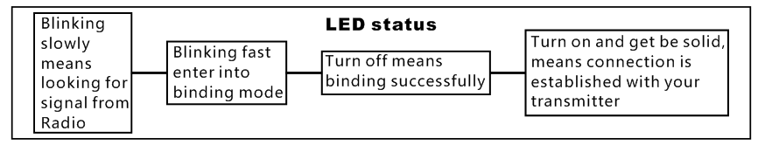


If you flashed the firmware or erase chip, please first do the bellowing procedure , don’t connect the battery otherwise the motor will auto-spin
- Cleanflight: Go to the CLI tab, type “Set motor_pwm_rate=1000” ,then enter save
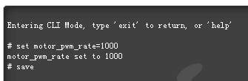
Betaflight: Go to Configure Tab and set ESC/Motor protocol to BRUSHED
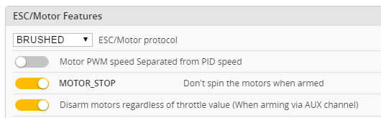
*This step is in order to avoid motor auto-spinning when connect the battery

