GPS Tracker Manual
GT01
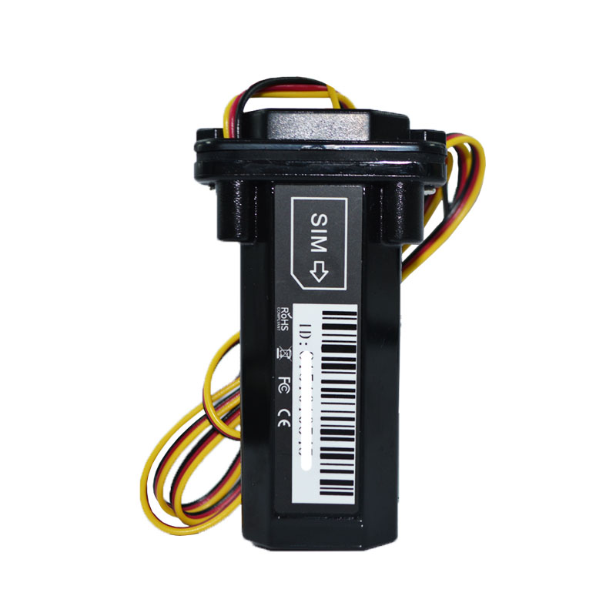
- Install mobile phone card
Select the SIM card(in maximum size) with GSM (GPRS) network.
Open cover with screwdriver, insert the SIM card( shown as the below right picture). The device default shut down, insert the phone card automatically power on.
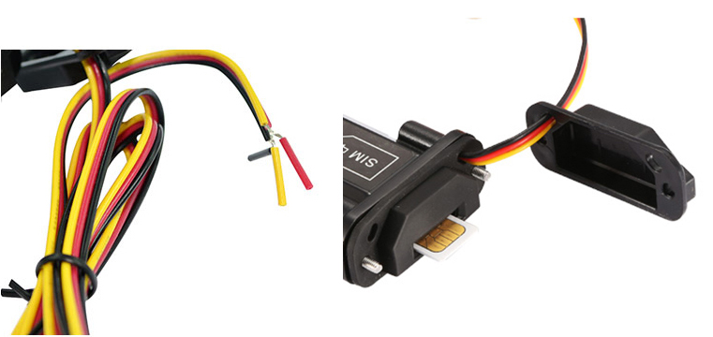
After you insert your cell phone card, please dial the SIM card mobile phone number, after dial tone, then hang up the device, which means normal reading card.

- Wiring
Red is positive, black is negative yellow is ACC
Battery voltage: DC 12-100V

- LED Status
Orange LED--- GSM signal status
Light On = GSM network connected Flash =GSM network searching or No SIM card
Blue LED: GPS signal status
Light On = GPS positioned Flash = No GPS Signal or GPS searching
Red LED: Battery status
Flash = Working Light Off = No Power

4.Set APN
First, setting up APN (If incorrect setting of APN, could not use the monitoring platform). If you are unsure of the SIM card APN you are using, please call the operator.
For examples:
APN=cmnet APN User name=blank APN Password=blank
Type message: apm123456 cmnet reply: apn ok
APN=Internet APN User name=gprs APN Password=0000
Type message: apm123456 internet reply: apn ok
Type message: apmuser123456 gprs reply: apnuser ok
Type message: apm123456 0000 reply: apnpasswd ok

5.Monitoring platform
Log in http://3.tkstargps.net Input tracker ID number:

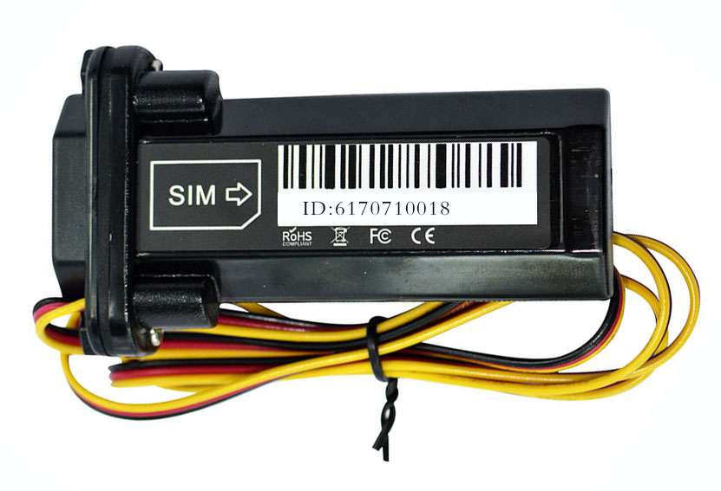
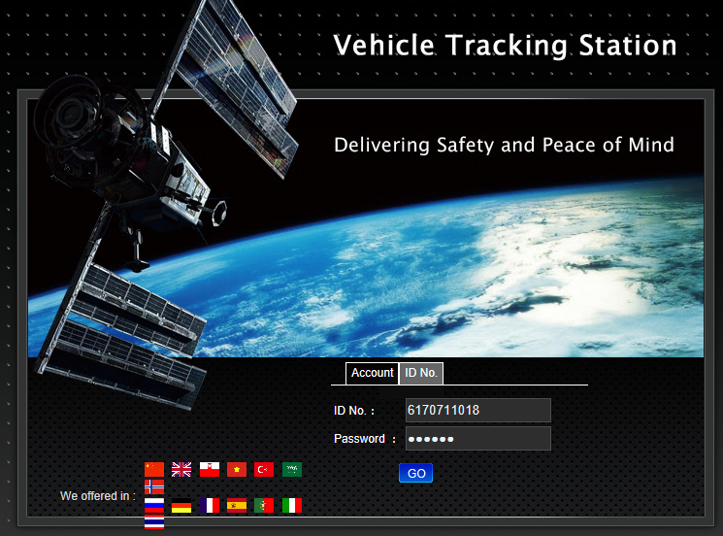

APP download；



IOS Android

Log in as the below pictures show

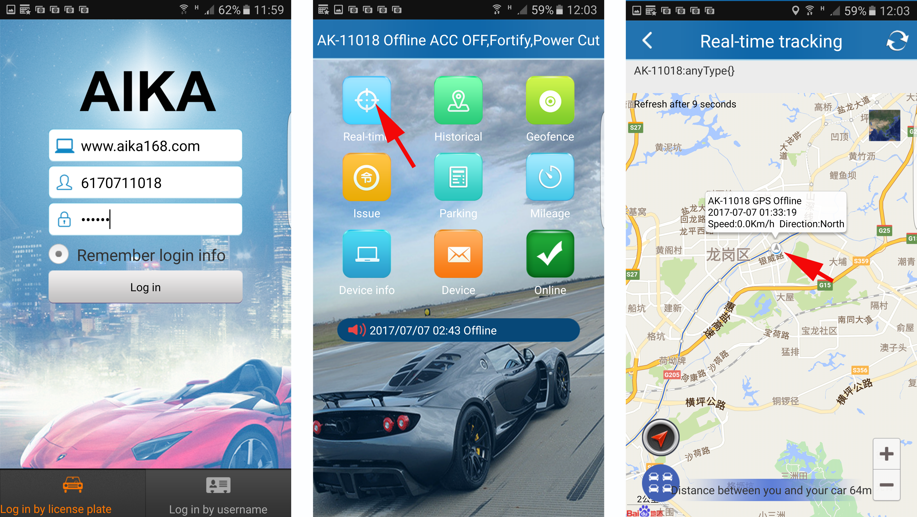

6.Set IP

If you want to use the custom monitoring platform, please change the IP address and port number in the following instruction format.

Instruction format: ip+ space + IP address + space + port

Example: IP 106.3.230.234 8185 (this IP address is default to the device)

Reply: SET OK

7.Set authorization number

The authorization number has the main authorization number and the secondary authorization number. Only the main authorization number can modify the password and send the modification instructions.

Set the main authorization number: 101#13800138000#

Setting the secondary authorization number: 102#13800138001#

Setting the secondary number: 103#13800138002#

Query authorization number: C10#, the device replies as follows: 101#13800138000 102#13800138001 103#13800138002

No more than 2 secondary authorization numbers are allowed to set. After the authorization number is set, only the authorized number can send command, and the unauthorized number can not send. After setting the authorization number, all alerts can be sent to the authorization number.

8.ACC setting

The orange ACC line must be properly connected.Connecting the ACC line when the engine is at start state, the the equipment will be into non alarm state automatically. If the ACC line is switched on when the engine is switched off, the device automatically enters a state of fortification.

Fortification status: turn on the engine to start the alarm to the authorized number.

Non alarm state: turn off the engine alarm.

You can use SMS or platform to send instructions to the equipment for non alarm and alarm(fortification) settings, set as follows:

Fortification: ACCLOCK, 123456,1 device reply: set successfully

Non alarm: ACCLOCK, 123456,0 device reply: set successfully

9. Vibration alarm function

The tracker is equipped with a vibration sensor, vibration alarm can be set to SMS alarm and telephone call alarm, the setting method is as follows;

SMS alarm: 125# delete this setting: 126#

Telephone alarm: 122# removes this setting: 121# (device is without microphone, can not hear the sound from car)

10.SMS alarm switch

If you do not need SMS alarm, avoid harassment, you can set as follows;

Close SMS alarm, edit SMS and send: CF Open SMS alarm: SF

11.Change the password

Modify the command password, edit SMS and send: password123456 666888 to your device phone number, device reply: password OK (666888 is your new password)

12.Over speed alarm function

Set the maximum speed value of your vehicle. If it is overspeeding, it will send an alarm message or call 3 authorization numbers. The setting method is shown as follows;

Turn on over speed alarm: edit SMS and send: speed123456 080 (080: maximum speed limit 80 km / h)，device reply: speed OK

Shutdown over speed alarm: edit SMS and send: speed123456 000，device reply: speed OK

13.Electronic fence

With the current vehicle as the center, a circular electronic fence can be set up for vehicle movement for alarm. The setting method is shown as follows:

Turn on the electronic fence, edit message and send: move 300 (300:300 meters radius) device reply: move OK

14.Assistant instruction

  - Restore factory settings,text and send：FORMAT
Device reply：Restore factory value successfully.Please reset the owner's number!
  - Query device information：CXZT
Reply：
XM_GT09_SW_20.0 2017/03/13
ID:6170711018
IP:106.3.230.225 8185
BAT:3
APN:CMMTM
GPS:A-25-00
GSM:17
ICC89860116851015935693
Frequently-used Command


