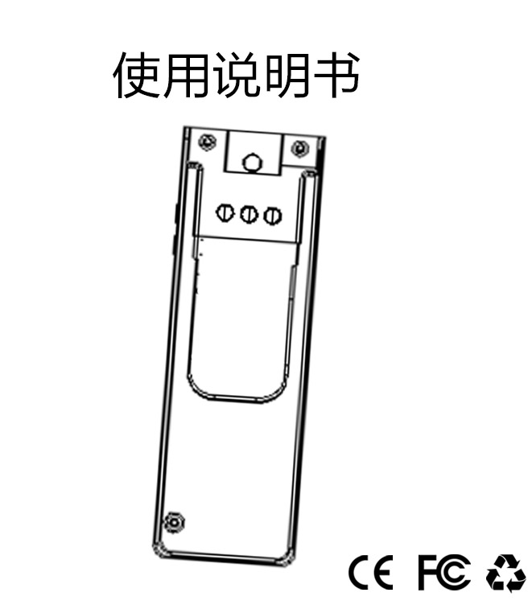
Operation Instruction
Cover

I. Product parameters
1. Video or voice recording while charging
2. Night vision function.
3. Video format: 1280×720P and 1920×1080P
4. Motion detection (setting)
5. One key separately recording
6. Support high-capacity TF card of 8--128G
7.Network camera function
8. The camera can rotate 180 degrees
9. Support loop recording

Page 1

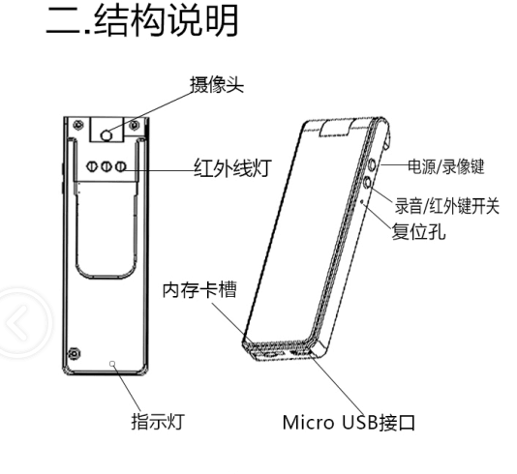
Sound recording/infrared lamp switch
Reset hole
Description of structure
Micro USB interface
Indicating light
Memory card slot
Infrared lamp
Power/ recording button
Camera

Page 2

III. Operation Guide 1
Charging:
This machine has a built-in rechargeable lithium battery, which shall be charged in first use as below:
1. Use the USB to connect to the computer for charging.
2. Use a battery charger of 500MAH for charging; connecting to a charge pal or battery charger for charging during camera shooting or recording can realize recording while charging;
3. The lamp is still on during charging, and it will be fully charged in about 3-4h.
4. If video recording cannot be carried out with the card inserted, connect this machine to the computer for formatting of the memory card: fat32 select 32k, exfat select 128k
Note:

1. It will stop video recording and sounding recording in low battery, and automatically save and shut down.
2. The blue lamp will flicker quickly without a card during start-up.
3. The blue and red lamp will flicker quickly at the same time when the memory card is full.
4. The machine will automatically shut down when it is idling for 3min (non video recording and recording state).
5. Note: Don’t use a high-power battery charger for charging in order to avoid shorten the service life of the battery.
6. Please charge the product in time after use to avoid it in low battery for a long time.

Page 3

Operation Guide 2
Starting up:
Long press the power button for 3 seconds, the lamp is on and it will power on.
Video recording:
Short press the “power/video recording button” in stand-by state, the blue lamp will slowly flash for a few times then go out and start video recording. Then short press “power/video recording button” to stop video recording and save, and the blue lamp is on.
The video recording will be save automatically in sections, 5min a section in circulation mode, 8min a section in non-circulation mode.
Sound recording:
Short press “recording key”, the red light slowly flashes for a few times and goes out; then short press “recording key” to stop recording and save, and the blue lamp is on.
The recording will be saved automatically in sections, 60min per section.
Open/close the infrared lamp;
Long press “recording key” for 2 seconds under standby and recording mode to open/close the infrared lamp, the red lamp is on/off.
Reset:
Use a toothpick to stab the reset hole for normal working when the product has no respond.
PC camera:
Connect to the computer without a memory card, and it can serve as a PC camera.

Page 4

Operation Guide 3
Setup:
The product support switchover between 720P and 1080P (default) recording, circulation recording (closed in default), movable detection (closed in default) and time watermark (opened in default).
The switch is user-defined. Users only need to insert the card to USB port of the computer, open the txt document named as SETTINGS in root directory of the TF card, in which there are the contents of “1, 0, 0, 1” in default. 4 figures can choose 0 or 1 (the first figure: 0 is 720P, 1 is 1080p; the latter 3 figures correspond to circulation recording, movable detection and time watermark respectively: 0 is closing, 1 is opening). Modify the saved document, which will be effective after restarting. Deletion of this document will restore default settings.
Connection to computer
Use the USB data cable to connect to the computer, then it can read the memory card. A removable disk appears in my computer, click it, save contents of the video recording document as *:\VIDEO, and that of the recording documents as *:\RECORD.

Time for modification
Connect to the computer after inserting the memory card into the product and turning on the product, the memory card will produce a time text "settime.txt", open it and modify the time value then save it, for example: 2017-03-28, 23: 59: 59, respectively refer to 23:59:59, March 28, 2017. After succeeding, the time in the txt will restore to the initial time.

Page 5

Items | Relevant parameters
Video format | AVI
Video coding | M-JPEG
Video resolution | 1920 × 1080P FHD / 720P 30 frames (optional)
Image ratio | 16:9
Video frame rate | 30 fps
Play software | Operating system-provided or mainstream audio and video play software
Support system | Windows me/2000/xp/2003/vista; Mac os; Linux; Win7
Battery capacity | 680mAh
Video working time | 4 hours or so
Recording working time | 8 hours or so
Charging voltage | DC-5V 500mAh
Interface type | Micro 5 Pin USB
Storage support | Support TF card -8-128G (high-speed card is recommended)
Type of battery | High capacity polymer lithium

Page 6

Important note:
Please read this manual carefully before using the product and save it for future use.
1. The product does not provide internal storage, please insert the TF card before use and turn off the product before pull out the TF card.
2. In order to avoid the risk of data loss caused by misuse or malfunction of this product, please always carry out data backup on the computer.
3. The dispute arising from the camera shooting or recording without the permission of any other person shall be unrelated to the product and our company shall bear no responsibility.
4. Our company endeavors to ensure that the contents of the instructions are complete. Due to different technology and production batches, if there are contents inconsistent with the recording pen, the recording pen shall prevail.
5. From the date of sale (according to the date of purchase), one year of free warranty is provided for this product.
6. For self-disassembly, man-made damage to the product or exceeding the warranty period, corresponding costs of spare parts and other parts shall be charged during maintenance.
Special Note: for the repair of the product, just return the single machine; for memory card loss or loss of information during repair with card, our company shall bear no responsibility hereof.

Page 7

Warning:
In order to maintain product performance, do not store or use the product in a hot, cold, dusty or high humidity environment. For example, the bathroom, or directly exposed to direct sunlight or similar high temperature environment (such as internal of the car directly exposed to direct sunlight).
Do not get close to strong magnetic fields, such as televisions, sound equipment, induction cookers, microwave ovens.
Do not place the product in a place with intense vibration or instability, such as a car dashboard or an unfixed shelf.
Safety:
Do not attempt to disassemble or refit this product.
Do not place foreign matter in this product.
Prevent the product from dropping or falling into the water or in the fire.
If you do not use it for a long time, please charge / discharge the product once every other month.

Page 8

