Smart Clean Mask
Manual

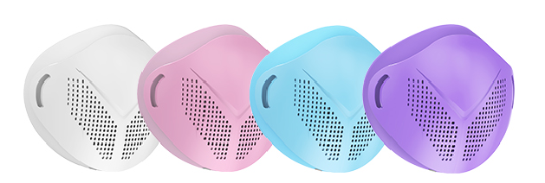

Thank you for using this health smart purification product, which will carefully explain how to take care of your health

This Smart Clean Mask is designed to allow the body to breathe better air quality and take care of the user's health.
Coupled with a strong filter and the overall efficiency of the fan, but also with intelligent Bluetooth chip and the internal powerful PM2.5 detector, the entire system by the APP central system of control, so that users at a glance!

A. Product content
Mask Device x1
Modeling Cover x1
Filter element x5
Soft Filter fixed x1
Soft Mask Partx1
Straps x1
Manual x1
Micro USB Charging Cable x1

Active air-type anti-fog haze intelligent masks, the use of 4 heavy protective filter, the air PM2.5 effective intercept rate of 99.7%, can be applied to daily protection for the user to provide clean air, effective protection of daily air in the virus, Bacteria and other pollutants;
●This product is divided into children's version (under 12 years old), adult version, this product is suitable for adult use according to the size of the user's age face
●This product has Bluetooth function, the user can access the phone through the Bluetooth signal APP, real-time view filter values;
●This product filter according to the weather pollution, polluted environment is recommended to use 2 to 3 days
General use available 1-7 days
●This product filter, headband, silicone ring, the front cover is a consumable, for replacement, please go to APP mall, or contact the dealer
B. How to Use

1 Install the filter cartridge on the cleaning mask
Filter sleeve fixed on the soft, along the positioning hole installed to clean the mask host, and press fit

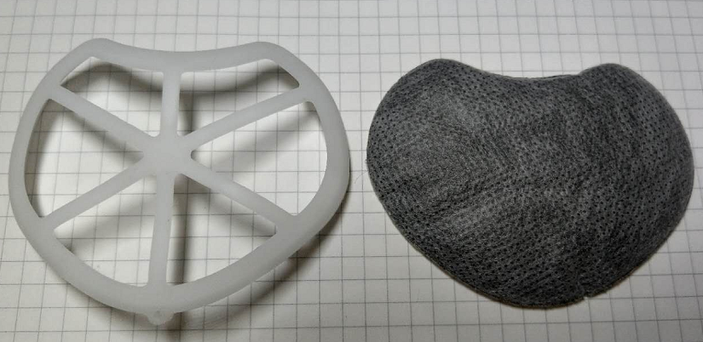

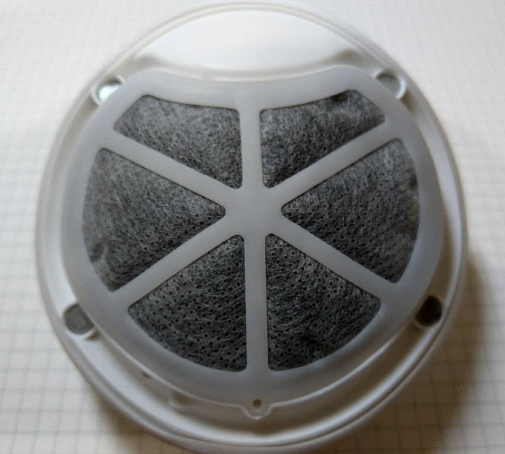
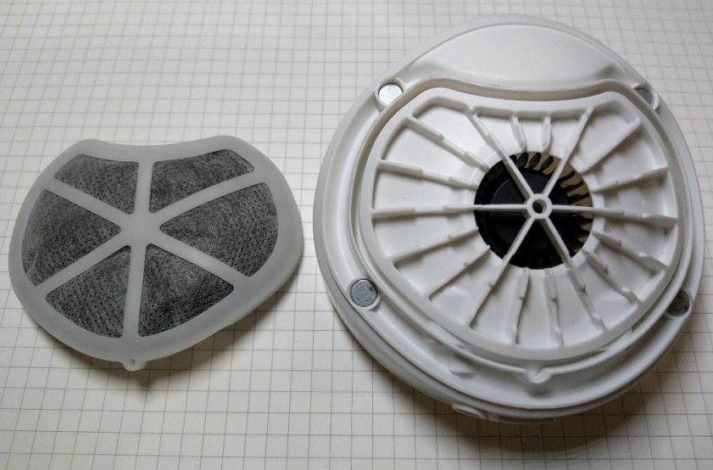

2 If the device is no power, insert the Micro USB charging cable into the charge
Charging: flashing green light
Full of electricity: bright green light
No electricity: flashing red light

Continuous start fan use: 4 to 6 hours
Full charge time: about 2 hours

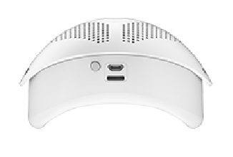
3 Press the button to turn on the fan
There will be three wind speed, press the button to control the fan in order: weak / medium / strong / off

4. Headband installation
The headband at both ends in turn through the head of the headband fixed hole, and then installed at both ends of the buckle, through the buckle can adjust the size of the headband to the appropriate proportion
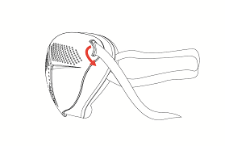

5. Wear
The smart masks fit the face, the assembly of the headband through the head, the headband at both ends of the card placed in the head;
The buckle at both ends of the headband is fastened from the rear of the head;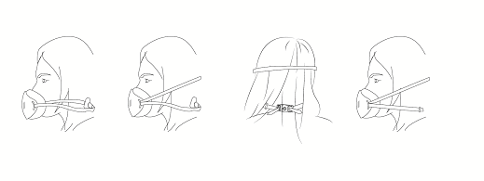

6. Replacement of supplies
This product filter according to the weather pollution, according to the use of the replacement of the filter.
Suggested pollution of serious environmental areas, the use of 2 to 3 days for new filter.
Such as the use of the general environment, the proposed 3 to 5 days replacement.

This product filter, headband, silicone ring, the front cover is a consumable, for replacement, please go to APP mall, or contact the dealer

Part C. Use APP
Can download iOS & Android related APP software

iOS Apple Store Android
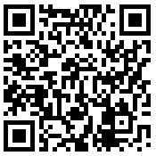
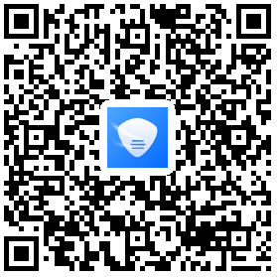

After the installation is complete, click APP to run
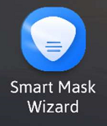
Power %

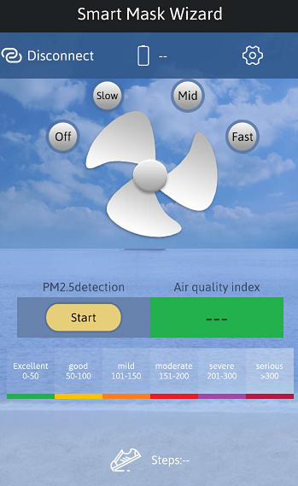
Bluetooth connection

Masks fresh air fans

Setting

PM2.5 detector
Start / stop button

Pedometer

D. Cleaning maintenance and precautions
1. When cleaning, please turn off the power, the host part contains electronic chips, you can use alcohol or wet cloth gently paint the mask shell, do not water or direct flushing; cleaning is completed, please use dry cloth dry or dry re-use;

2. Smart masks for personal protective equipment, for your health, do not share with others;

3. Silicone ring and headband parts are food grade silicone, removable with alcohol paint after disinfection, or use a small amount of detergent fine hand wash and rinse with water;

4. When the product is not used for a long time, please turn off the power and recommend to charge once a month to extend the battery life

5. This product is only used for personal daily protection, not as a special working environment under the use of labor insurance products, not as toxic gas protective equipment;

6. Contains precision electronic chips, please do not open, please do not bare metal drop;

Technical specifications
Name: Smart Clean Mask (Bluetooth version)
PM2.5 effective interception efficiency: > 99%
Battery working time: continuous use of about 5 to 6 hours
Product weight: 110g
Product size: 10x11x7 cm

