User manual of MK8/9
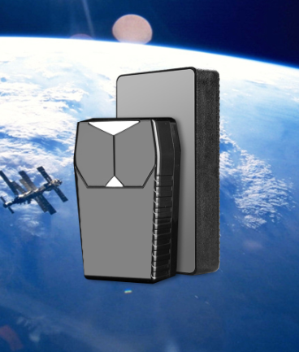

To install equipment correctly and using equipment quickly, before using the device, please read user manual carefully. Pictures are only for reference, please take practicality as standard.
- Using methods
- Before using, please check model number of equipment and accessories.
- Please open dust plug, and install SIM GPRS card ( support SIM card of CMCC and China Unicom).
- Please record IMEI number at back of equipment to use for enquiry location.

- Install indication
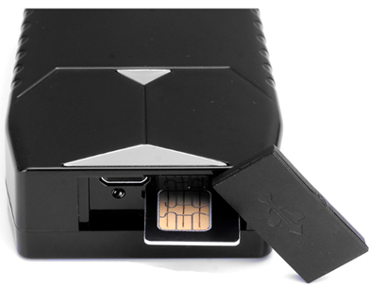
After installing SIM card, it will power on automatically, and blue indicator light will flicker for 3 seconds.

- Methods of query positioning.
- Please input website of www.gps902 .net, then input IMEI number and password to login and query positioning. IMEI number is at back of rear cover, default password is 123456
- Please use mobile phone to scan QR code and download APP, then use device number and default password to login and query positioning.
- Please add official accounts of “GPS cloud service” on Wechat, then input @IMEI number#123456 and bind. After binding, please send 123 to query positioning.
QR code of APP QR code of WeChat

- Parameter of equipment
Power: min version 4000mAh | persistent version 8000mAh
Size: min version 7*4.5*2cm | persistent version 10.5*5.3*2.3cm
Standby time: mini version latency 300days standby 60days | persistent version latency 600days standby 120days
Safe mode—real-time positioning
Power saving mode----Moving to open positioning function, it works by motion sensors.
Super-long time standby—When it is latency, all data will not be upload, it is needed to switch to safe mode to activate.
As to commands of opening functions, please refer to page9 ( about standby time )
Suitable groups: personal tracking, pets tracking, car/motorcycle tracking
Accuracy of positioning: <5M ( GPS )
Positioning ways: GPS+AGPS+GMS
GSM frequency bands: 850M/900M/1800M/1900M, worldwide available
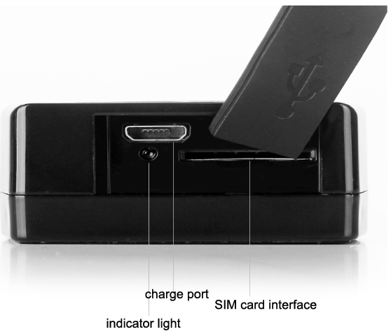
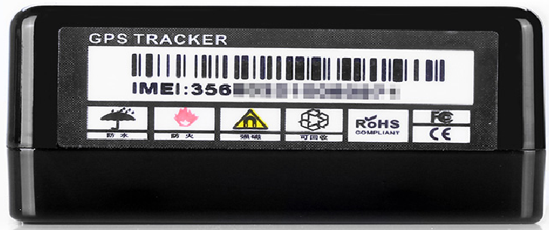
IMEI number at bottom

- Functions of equipment

- GPS real-time positioning
- Query 60 days historical route
- Vibration alarm
- Electronic fence
- Mutil-modes working
- Mutil-stages to query: APP/WeChat/SMS/PC
- Worldwide available
- Low power alarm

- Using instruction
- Bind WeChat to query
Please add official account “GPS cloud service ” in Wechat, then input @IMEI number#123456 to bind. After binding, please send 123 to query real-time position.
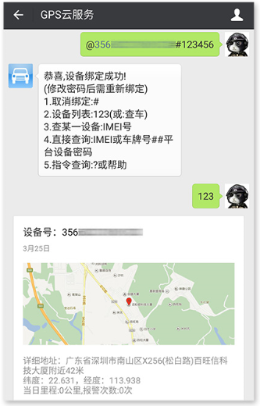
- Bind mobile phone to query
Number is bound by command. Please send SMS “CENTER,000000,your phone number#” to phone number of equipment’s SIM card ( The mobile phone number used in equipment), then equipment will reply CENTER OK automatically. That means binding is success. If it replies PASSWORD ER, that means binding is fail.
After binding and alarm function has been opened, alarm message will be sent to bound phone number automatically. If it is only used for monitor location, phone number no need to be bound.

- SMS query positioning
Please send SMS “123” to phone number of equipment’s SIM card, then equipment will reply current position automatically.
Please send SMS “URL#” to phone number of equipment’s SIM card, then equipment will reply map link of current position.
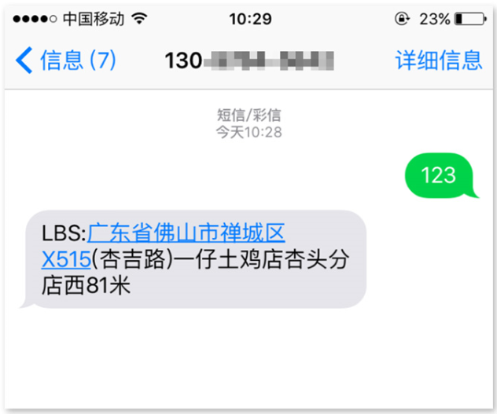
(4) Vibration alarm
Please send SMS “ZD,1#” to phone number of equipment’s SIM card, then equipment will reply “ZD OK!”. That means vibration alarm function is opened successfully. If you want to close this function, please send SMS “ZD,0#” to equipment.
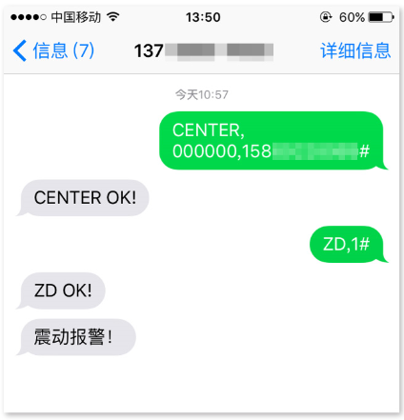
(5)APP query
Please scan QR code in user manual or search APP in website to download and install APP.
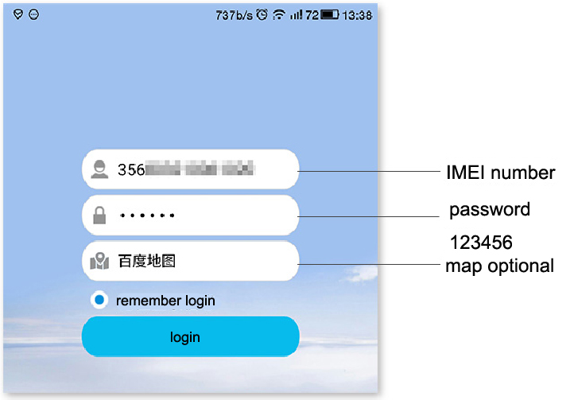
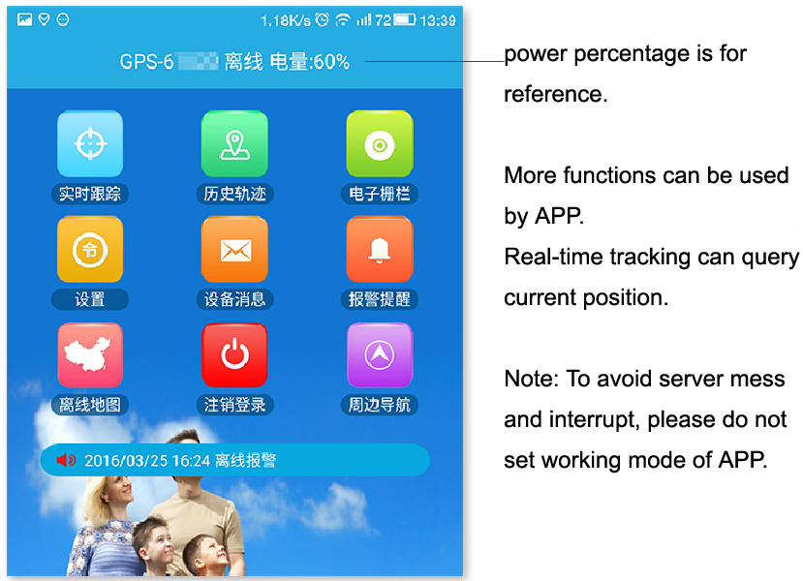
(6) Electronic fence
You can set scope of fence by APP. When equipment is out of the scope, it will alarm to monitor.
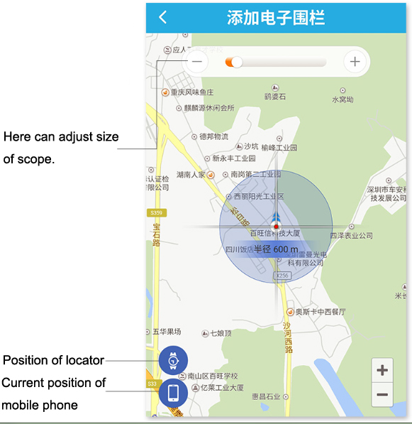
7. FQA
(1) About standby time
There are many factors will influence standby time of equipment, such as using frequency, moving frequency, signal strength etc. If standby time is too short, please charge equipment for 5 hours with SIM card in it, then change mode to super-long time standby mode. The standby time will be longest.
Safe mode: real-time positioning, accuracy is very high, but it will consume very much power.
Power saving mode: It assists to positioning. Accuracy is not same in different cities. Power can be saved.
Super-long time standby mode: only when SMS is sent to change equipment to safe mode, equipment will be online. It can save much power.
SMS commands:
wkmd, 0# ---- safe mode
wkmd, 1# ---- power saving mode
wkmd, 2# ----super-long time standby mode

(2)Position on stage is updated slowly or no update
When position of equipment is no updates, please ensure equipment has been set to safe mode.
If equipment has been set to safe mode, and position is still not update, please send SMS “reset#” to phone number of equipment’s SIM card. It will take around 3mintues to update current position of equipment again.

(3) How to judge if equipment has been power on and working.
After installing SIM card, equipment will power on automatically. Blue indicator light will light off after several seconds flickering. Then please login account and check if it is normal.

(4)Charging notes
When charging power, SIM must be installed in equipment, otherwise, equipment can not be charged successfully. During charging, blue indicator light will light on, that means equipment is charging. It usually charges for 5 hours. After fully charging, blue indicator light will light off. When charging, please do not regard APP’s power percentage as standard.

(5) After installing SIM card, indicator light flicker all the time.
If indicator light flickers all the time, please check SIM card direction is correct or not. After installing SIM card correctly, please put equipment at open outdoors and wait for 10 minutes. When equipment receive signal, it will work normally.

