（）User Manual

User Guide

Hongkexin Electron Technology Co., Ltd

MP3-035F is a new generation media player, supporting MP1, MP2, MP3, WMA, WMV, ASF or WAV files. Its perfect tone in high reliability with refined exterior design brings you an ultra performance.
Overview
●Refined exterior design
Unique design fits for hand.
●Multi file format support!
This player recognize MP1, MP2, MP3, WMA and video in WMV, ASF, WAV and AMV formats.
●Firmware upgrade available
You can download upgrade software from website enhancing player’s function.
●FM stereo radio
Powerful automatic or manual tuning capability, save up to 40 channels (20 channels in each system).
●e-Documents
You can download text files into the player and read it any time as you like.
●Driver free USB memory
Manage your files in USB memory without specified software, no need drivers in WIN2000 or furthers.
●’Secret Space’
You can separate part of the memory encrypting and hiding in using programs provided, where data cannot be seen or written by others.
●Recorder / Repeat
Voice can be recorded and saved in WAV or ACT format. Phase/Contrast repeat available.
●Equalizer
Normal, Rock, Pop, Classic, Soft, Jazz, Bass
● Play modes
Normal, Single Repeat, Play Catalog, Repeat Catalog, Repeat All, Shuffle, Lyric.
●Timing turning off
The player provides Sleep and battery saving mode, more convenience for you!
●Complete dynamical menu
Visualized dynamical menus with text instructions make you easy control.

Declarations
Welcome to choose our produce, please read this manual carefully.
Functions and performance may change without prior notice.
If any difference between produce and this manual, please visit our website

Contents
- Overview…………………………………………………………………………………………………………2
- Declarations………………………………………………………………………………………………………2
- Know your player………………………………………………………………………………………………5
Exterior and Keys………………………………………………………………………………………5
Display………………………………………………………………………………………………………5
Battery Level………………………………………………………………………………………………5
- Basic Functions…………………………………………………………………………………………………6
Access to Menus…………………………………………………………………………………………6
Scrolling……………………………………………………………………………………………………6
List of Menus……………………………………………………………………………………………6
Volume Adjust……………………………………………………………………………………………7
Switch On/Off……………………………………………………………………………………………7
Play & Stop………………………………………………………………………………………………7
Start/Stop Recording……………………………………………………………………………………7
Recording / Pause…………………………………………………………………………………………7
- Keys Processing…………………………………………………………………………………………………7
Keys function definition…………………………………………………………………………………7
Keys processing definition………………………………………………………………………………8
- Play music………………………………………………………………………………………………………8
Simple Actions……………………………………………………………………………………………8
Equalizer mode……………………………………………………………………………………………8
Synchronous Lyric Settings……………………………………………………………………………9
How to display lyric?………………………………………………………………………………………9
- Voice Recorder…………………………………………………………………………………………………9
Recording on ‘Record Mode’……………………………………………………………………………9
Start Recording Type……………………………………………………………………………………10
Voice control………………………………………………………………………………………………10
Play recorded files………………………………………………………………………………………10
- Convert ACT into WAV…………………………………………………………………………………………11
- Using FM radio…………………………………………………………………………………………………12
- Settings…………………………………………………………………………………………………………12
Entry settings……………………………………………………………………………………………12
Option introductions……………………………………………………………………………………12
‘Recording time’…………………………………………………………………………………………13
‘Screensaver’……………………………………………………………………………………………13
‘Language’………………………………………………………………………………………………13
‘Turning Off’………………………………………………………………………………………………14
‘Repeat’……………………………………………………………………………………………………14
‘PC Connection’…………………………………………………………………………………………13
‘Memory Status’…………………………………………………………………………………………14
‘Firmware Version’………………………………………………………………………………………14
‘Upgrade Firmware’………………………………………………………………………………………14
- Reading Documents……………………………………………………………………………………………14
- Browsing Pictures………………………………………………………………………………………………15
- Using USB Disk…………………………………………………………………………………………………15
- Upgrade Player…………………………………………………………………………………………………15
- Other Settings…………………………………………………………………………………………………17
Change Folders…………………………………………………………………………………………17
Delete Files………………………………………………………………………………………………18
Play Mode…………………………………………………………………………………………………19
Tempo rate………………………………………………………………………………………………19
Repeat Mode……………………………………………………………………………………………19
A-B Repeat…………………………………………………………………………………………19
Karaoke……………………………………………………………………………………………20
Contrast Function………………………………………………………………………………………20
Repeat Times……………………………………………………………………………………………20
Repeat Interval……………………………………………………………………………………………20
- New Function Recommends…………………………………………………………………………………24
Secret Space Function…………………………………………………………………………………26
invert Video files into AMV………………………………………………………………………………27
- Troubleshooting………………………………………………………………………………………………29
- Technical Specifications………………………………………………………………………………………30

Know your player

Exterior and Key
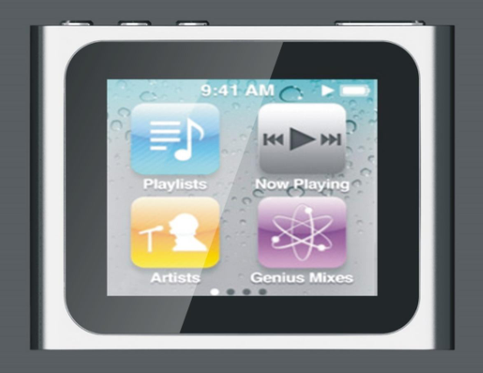
- Vol+/Next
- PLAY
- Vol-/Last
- MODE

Displayer
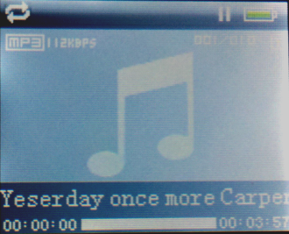

Battery Level
The player shows capacity in 9 levels
Battery is full on 3.8V. As time goes on, capacity indication will monish.
Indicator shows blank when battery almost ran out. You should charge your battery at that time.
Please switch on the player before charge. This player cannot be charged in case of power off/
Please switch off power when not using the player.
Basic Functions
- Access to Menus
Press Mode to access menus.
- Scrolling
○ Scroll music, menus
○ Fast Forward / Reverse when playing music.
- List of Menus
To access different menu functions from main menu.
Main menu: (Hold Mode to access)
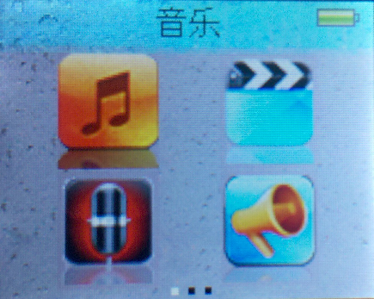
Video play:
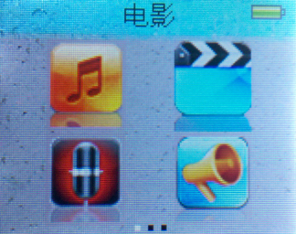
Music Mode:
Recorder Mode:


FM Mode:
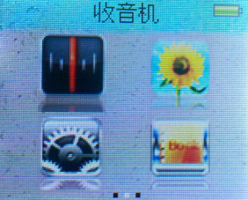
Browsing pictures:
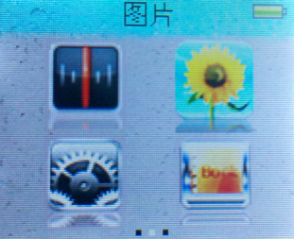
Settings:
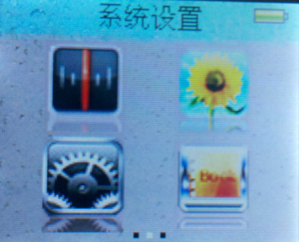
E-Documents:
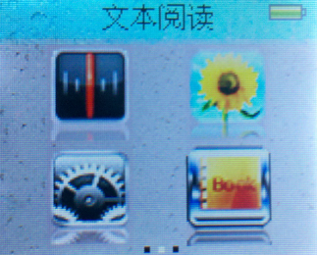

USB Mode (Connect to PC):


- Volume Adjust
Press VOL+ to increase volume, press VOL- to decrease.
- Switch on/off
Press and hold Play to switch on when the player is off.
Press and hold Play to switch off when the player is on.
- Play & Pause; exit from submenu
On music mode, Press Play to play music.
When playing music, press Play to pause; press and hold to stop playing.
- Start / Stop recording
On recording mode, press Play to stop.
Keys Processing
  - Keys Functions Definition
- Play: Power On/Off, Play, Pause, Stop
- MODE: Entry main menu or exit from current menu.
- REC: Entry voice record interface.
- A-B: Access Repeat Mode interface..
- VOL+: Volume increase
- VOL-: Volume decrease.
- Next: Next, FF, Volume increase
- Last: Previous, Rev, Volume decrease
- USB: USB outlet
- Earphone: Standard earphone outlet
- ON/OFF: Power switch

  - Key Processing Definition
Keys processing includes 4 actions: Press, Press and Hold, Push, Hold. If not mentioned, all actions are Press.
Press: Press a key and valid immediately;
Press and Hold: Press a key and hold it at least 1.2s this action valid only once.
Push: Push a key, and valid when released.
Hold: events occur in such frequency then the key is holding such as Fast Forward and Reverse.
4、Play music
- Simple actions
- Put earphone plug into earphone outlet;
- Press and hold Play to switch the player on, then entry Music Mode and press Play to play music.
- Select a music: Last: Previous music;
Next: Next music.
4．For AMV files, video play will apply.

- Equalizer Mode
- When playing music
- Press Mode to entry play submenu;
- Push Next choosing Equalizer Mode;
- Press Mode to entry ‘Equalizer Mode’ submenu.
Select an equalizer: 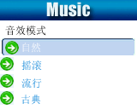
- Detail of each equalizer (EQ):

Natural
Rock
Pop
Classical
Soft
Jazz
DBB
- Push Next to select an EQ and press Mode to confirm.

- Synchronous Lyric Display
The player supports lyric files with *.LRC suffix, and displays synchronously.
How to use lyric files?
Please make sure the lyric has the same name to the music
For example:
Music file: Journey.mp3
Lyric file: Journey.lrc
How to know if lyric available?
Press and hold Mode to entry lyric interface;
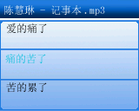
  - Lyric displays
  - Press Mode return to music mode.
Voice Recording
Please make sure the battery has enough capacity before making record.
Each fold can save up to 99 voice recording files.
- Recording on “Record mode”
1. .Entry main menu:
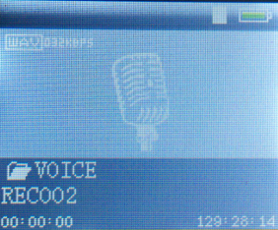
2. Push Next scroll to Record mode
3. Press Play to start recording.
Voice will be recorded in current fold which set through ’Record stop / Main fold’
If displayed “Memory full”, it means mo space to save new record files, please delete other files to release memory space.
If “Fold full” shown, it means there are 99 record files in this fold. Please choose another one.
The player only responses to Play and A-B when record processing

- Select Record Type
1. When in the interface of ‘Record stop’
2. Press Mode to entry record submenu
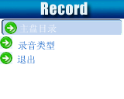
3. Push next scrolling into ‘Record type’ submenu then presses Mode to select it.
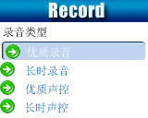
Fine record | wav file，fine quality
Long-time record | act file, normal quality
Fine voice control | wav file, (Recording controlled by voice, pause when mute)
Long-time voice control | act file, (Recording controlled by voice, pause when mute)
4. Press Next to choose appropriate type and press Mode to select it
5. Press Play to start recording.
Play recorded files
- Entry main menu
- Push Next to choose ‘Play mode’
- Push Mode to entry playing interface
- Press Play again to play the file.
- Choose voice record files。
Last: Select previous file;
Next: Select the next file;
Convert ACT Files into WAV format
The ACT file which produced by this player can be converted into WAV format by using software provided.
1. Imply “Sound Converter” program. Clock “OPEN” button
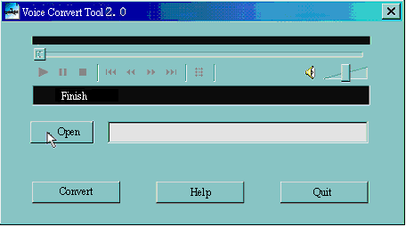
2. Select the ACT files you would like to convert
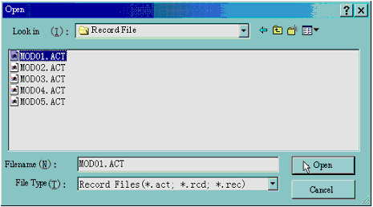
3. Click ‘CONVERT’ button, the program will start converting
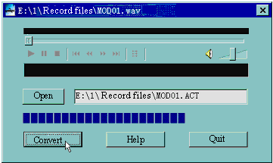
PS: This tool can also play WAV and MP3 files.
Using FM radio
1. Entry main menu;
2. Push Next scrolling “FM Mode”
3. Push Mode to entry
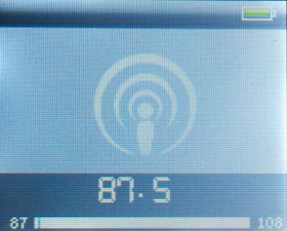
4. Auto tuning
Hold Last/Next 2 seconds to start the channel search in 100 KHz interval upwards or downwards. To stop tuning, push Last/Next.
5. Manual tuning
Push Last: Downward 100 KHz
Push Next: Upward 100 KH
6. Save current channel:
Push Mode to entry FM submenu
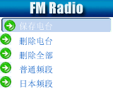
Press Mode again to save channel.
7. Listening to a saved channel:
You can press Play to choose a saved channel.
9. Volume control
VOL+: Increase volume;
VOL-: Decrease volume
：20 channels can be saved each in “General Frequency” and “Japan Frequency”

Settings
- Entry Settings
You can set system performances here, options may vary in different firmware version
1. Entry main menu
2. Push Next Scrolling into “Settings”
3. Press Mode to entry.
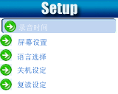

- Options introduction:
(Recording Time) | Setting date and time when saving recorded file
(Screensaver) | Screensaver setting
(Language) | Choosing different languages
(Timing shut off) | Setting a count down time in minutes, the player will shut off when time out.
(Repeat Setting) | Setting repeat status
(Contrast Setting) | Setting display’s contrast
(PC Mode) | Options for ‘Secret Space’
(Memory Status) | Check memory space and usage status
(Firmware Ver.) | Version of player’s firmware
(Upgrade Firm.) | Use for upgrade firmware
(Exit) | Exit from Setting interface
- List of menus:
○’Recording time’ Setting
    - System setting interface
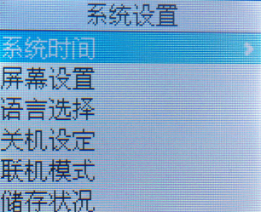
2. Press Mode to entry ‘Recording time’ interface
Recording time:
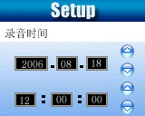

- Push VOL+ setting from years (VOL- from seconds). While setting, year on twinkling.
- Push Next the value will increase (Last on opposite)
- After setting, press Mode to exit.
○ “Screensaver” Setting
- Press Mode entry screensaver setting;
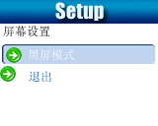
- Push Next for choosing (Last for previous)
- After setting, press Mode to exit.
○ Language Setting
This player has 17 display languages: Simplified Chinese, English, Traditional Chinese, Japanese, Korean, French, Germany, Italian, Spanish, Portuguese, Dutch, Swedish, Czech, Danish, Polish, Thai and Russian.
- Press Mode to entry ‘Language’ interface
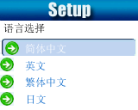
  - Push Next / Last to scrolling.
  - After setting, press Mode to exit.
○Turning off Setting
Please note:
You can set time in seconds on ‘Battery saving’ mode, allow the player shut down automatically when player become stop and idle for the period you have set. This function id void if the time set to 0.
You can set time in minutes on ‘Sleep mode’, allow the player shut down automatically when the player become idle (regardless current status) for the period you have set. It is designed for listening music before sleep. Please note: Sleep mode valid only once after setting, you have to set again if you want to use it next time.
○’Repeat Settings’
Please consult into ‘Sound Setting’
Note: in “Manual Mode” you should set repeat point manually.
In “Automatic Mode” the player can identify sentence automatically when on A-B repeat. (This function is designed for repeat sentences in language studies.)
○’PC connection’ Setting
Please consult into ‘Sound Setting’
Some operation systems (Windows 2K SP4 or prior) may not recognize a USB disk with two symbols. Therefore, you have to choose an active disk here when using ‘Secret Space’ function only the active disk can be found in PC.
○’Memory status’
You can check total memory space and the percentage of usage.
○’Firmware version’
You can find the player’s firmware’s version.
○’Firmware upgrade’
Use for upgrade player’s firmware.
Tips: Press Play can exit current menu quickly. The function is valid on all other menus.

Play Videos
1. Entry main menu, press Next scrolling to “MOVIE” (Only available to AMV files):

2．Press MODE to entry:
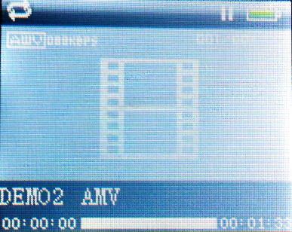
3．Press PLAY to starting play

- Reading Documents

１.On main menu, press Next/Last choosing e-Document,
２.Press Mode to entry corresponding submenu:
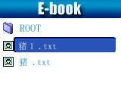
３．Press Next or Last choosing the document you want to read, then press Play to read it.
Note: If you are set in ‘Manual play’ you must scroll text via Next or Last; texts can be scrolled automatically under ’Auto play’ set.

- Browsing Pictures
This function is only available for JPEG format.
- On main menu, press Next/Last choosing Browsing pictures.
- Press Mode to entry corresponding submenu:
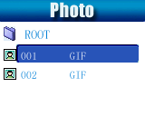
3. Press Next or Last choosing the document you want to read, then press Play to play it..

9、Using USB Disk
The player is also a standard USB disk. Supported by Windows98 (drivers needed), Windows 2K or above (no need for drivers), Mac OS 10.3, Red hat Linux 8.0 or above.
The player supports USB power supply, can be used without battery when connected to PC. To entry, when on在’waiting mode’ press Mode return to main menu and choose the operation you need.
This player supports Suspend mode.
When connected to PC, The player works on the three modes below:
1. Waiting | 2. Downloading
3. Uploading

10、Upgrade your player
You can use Pc software to maintain or upgrade player’s firmware.
- Entry main menu
- Push Next scrolling into ‘Settings’
- Push Mode to entry ‘Settings’ submenu.
- Push next scrolling into ‘Firmware upgrade’ and push Mode to entry.
- Connect player to PC
- Running upgrade tools MP3 Player Update, then click ’Choose new firmware;
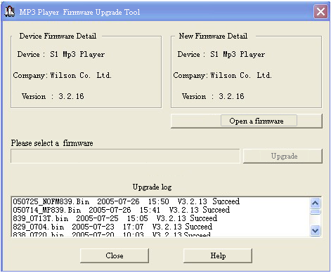

7. Select a firmware file. (Can be found on CDROM provided or downloaded from Internet)
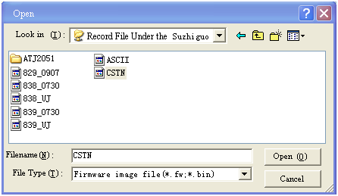
8. Click ‘Start Upgrade’, the upgrade will on process.
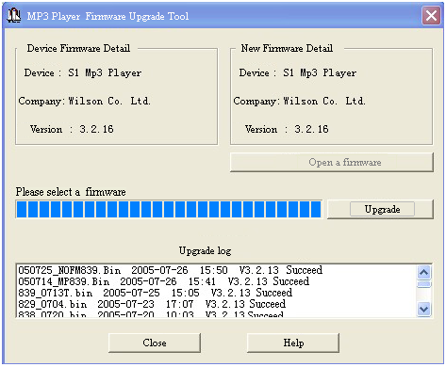
10. While upgrade successful, the player will display like this:
Firmware upgrade is to improve player’s performance; you can still use it normally without doing upgrade process
Player may not work by incorrect process! Please read this manual carefully before doing upgrade process.
The upgrade software cannot work for other player and vice verse.
Other settings
- Choose other fold (Stop submenu)
You can classify files into several different folders that ease to manage them (folders should be created on PC). The player can identify 9 folders in root
1. When stopped | 2. Press Mode to entry Stop submenu  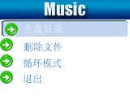
3. Press Mode to entry folder choosing interface  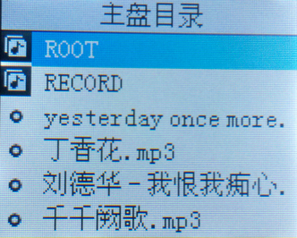 | 4. Press Next or Last to choose a folder
5. Press Mode to entry selected folder.

Please note: You can set folders independently in Music / Recorder / Play mode

- Delete file (Stop submenu)
You delete correspond files/channels in each Music/Play/FM modes.。
1When Stopped. (No stop interface in FM mode) | 2.Press Mode to entry Stop submenu  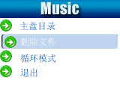
3. Press Next or Last to choose ‘Delete file’ or ‘Delete all’.  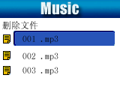 | 4. Press Mode to entry delete interface.  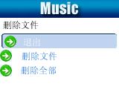
5.Press Mode to confirm delete


‘Delete all’ will delete all files in current folder of current mode. I.e. Choose ‘Delete all’ in Music mode will delete all music files; recorder files will not be affected.
On FM mode, all saved channel will be removed.
Please safely removed player and unplug USB cable after delete files on PC, otherwise some files will not be removed.
- Play mode (Play submenu)
You can choose different play mode (i.e. repeat, shuffle) when playing music or recorded files.
The first option on Play submenu is ‘Play mode’
○ REPEAT
(Normal) | Playing music files in sequence until the end of folder
(Repeat One) | Repeat single music file
(Folder) | Play all music files in folder
(Repeat Folder) | Repeat all music files in folder
(Repeat All) | Repeat all music files

○SHUFFLE
(Random) | Play music files in folder randomly

○INTRO
(Intro) | Play the 10s of each music files in sequence

- Tempo rate(Play submenu)
You can choose different play speed and not affect to sound. (Only valid to MP3 files)
- While playing music
- Push Mode to entry play submenu
- Push Next scrolling to ‘Play speed’ option
- Push Mode to entry
- Push Next for faster, Last for slower
Note:
Play speed will applied to all music file

- Repeat mode (Play submenu)
Press A-B to entry or
Entry from Play submenu:
○ A-B Repeat
1. When play music or recorder
2. Push Mode to entry play submenu
3. Push Next scrolling into ‘Repeat Mode’ option
4. Push Mode to entry
Repeat Mode: ‘A’ of Symbol flashes, waiting for starter A
5. Push Next to select ‘A’
‘B’ of symbol flashes, waiting ender B
6. Push Next to select B
Symbol fixed and starting repeat between A-B, while playing, you can push Last to reset A point.
In repeat mode, you can press VOL+ or VOL- to adjust playing speed

○ Karaoke Mode (No such Function in Playing mode)
1. A-B repeating | 2.Push Next entry Karaoke mode
3. Repeat symbol’ ’ will be replaced to karaoke symbol’ ’. Player begins recording voice to the length of A-B repeat period. | 4. Upon time reaches, player resume play music file and the symbol replaced to’ ’, push Next entry contrast function.
Press Last returns to Repeat A-B status.。

○Contrast Function (No such Function in playing mode)
1. While entry contrast function, repeat symbol displayed as“”, the original sound will be played. | 2. While finish original, repeat symbol will be replaced to“”, player will play the voice recorded.
Push Last return to ‘Karaoke mode’
Press Mode to exit repeat mode upon above three modes.
- Repeat times (Play submenu)
Please consult into ‘Backlight time setting’
Repeat time determines the times of play A-b repeat until exit
- Repeat interval (Play submenu)
Please consult into ‘Backlight time setting’
Repeat interval determines the time period between previous repeat (in seconds).

- New Function Recommends!
About Secret Space
Some MP3 user may worry about divulging secret. They do not want others to find private information contained, therefore these data have to be removed before lend their own MP3 to others. It makes some trouble.
However, this problem has totally solved by ‘Secret Space’ technique!
You can use provided software to divide the whole USB disk into two parts, and encrypt one of them. You can move your privacy into the encrypted part; they will be protected by password.
To active ‘Secret Space’:
- Connect your player to PC
- Run MP3 Player Disk Tool which can be found in provided CDROM
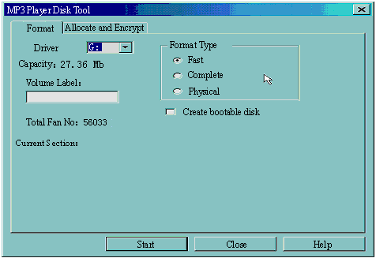
- Click ‘Allocation and Encrypt’ card, Allocate appropriate space and set username and password, and then click Start.
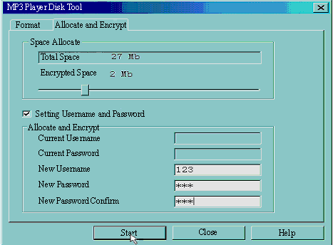
- After space allocation, shown as below:
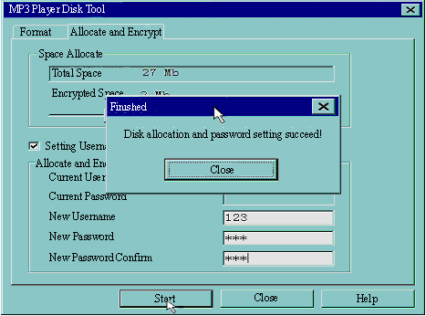
- Click ‘OK’ to restart.
- After restart you will find two disks (only one disk can be seen on Windows 2K SP4or prior), click the encrypted disk (the second one), you will find three files, two are hidden, one is executable
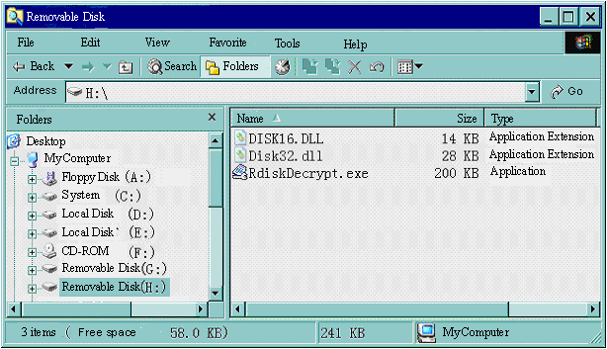
- Running executable file ‘RdiskDecrypt.exe’ and input username and password. If all are correct, disk will be opened, and files can be copied into.
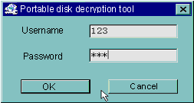
- You must enter username and password each time access encrypted disk.
Warning: Divide one disk into parts will remove all data, and so does combine process.
Warning: Please remember username and password. If you forget it, you can only making combine processing and you will loss all encrypted data.

Convert Video files into AMV
This program is used to convert video files into AMV format, currently only WMV format is supported.
1． Run “AMV Convert Tools”, click to choose the folder where to save the AMV files, then click to select the folder where the original files are 。
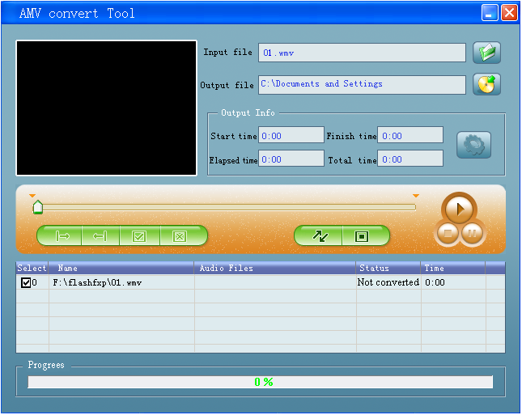
２．Select unprocessed AMV files, then click, the icon will be highlighted into  and a dialog box will shown. Choosing Pixels of AMV to “128 * 96” and Frames per second to “middle”, then click OK to confirm. (Note: Only pixels in 128*96 can be supported)
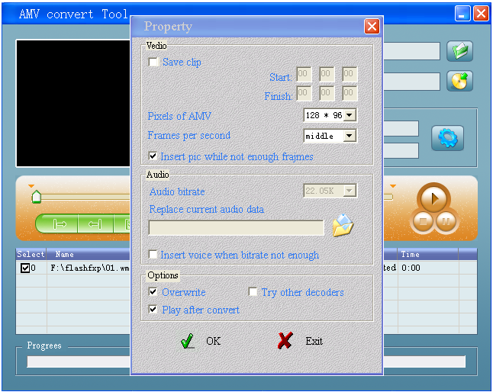
３．Click to start converting。
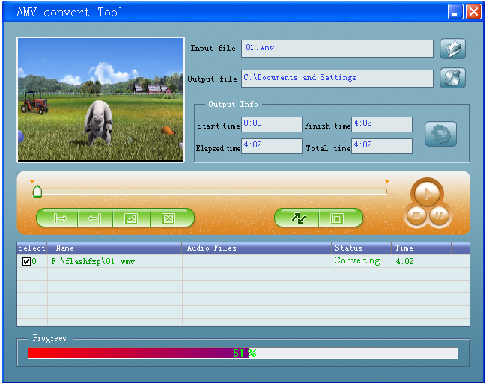
4．After convert, the AMV files will be played automatically.
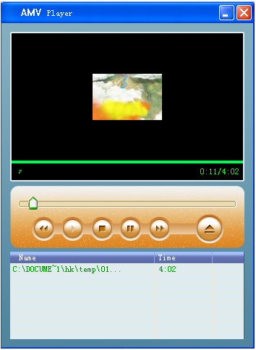

●Troubleshooting
No Power | Check if battery had installed properly  Make sure you have switched the player on
No Sound | Make sure volume is not on 0 position and the connection to earphone is valid  Please make sure the earphone is clean  Damaged MP3 files may have noise and even cannot be played
Strange characters on display | Make sure you have chose correct language
FM has bad performance | Adjust place of player and earphone  Switch off power appliance nearby  Earphone can be used as antenna
Cannot Download Music | Check USB cable, and make sure the player is properly connected to the PC  Check if the driver has well installed  Make there is still blank memory

Technical Specifications
Dimension
Weight
Screen | 1.8TFT (128*160) 2.0TFT(176*220)
Connecting to PC | High Speed USB1.1 (Read 1000K Byte, Write800K Byte)
Memory | 128M – 256M Flash
Power Supply | Max 10 hours play mode
Voice Recorder | Sample rate | 8KHz
Voice Recorder | Format | WAV (32K bps), ACT (8K bps)
Voice Recorder | Time | 35hours (ACT, 128M Flash)
MP3、WMA、WMV、ASF | Max. Output | (L) 10mW + (R)10mW (32Ohm)
MP3、WMA、WMV、ASF | MP3 Bit rate | 8K bps – 320K bps
MP3、WMA、WMV、ASF | WMA、WMV、ASF Bit rate | 5K bps – 384K bps
MP3、WMA、WMV、ASF | Freq. Response | 20Hz to 20KHz
MP3、WMA、WMV、ASF | SNR | 85dB
MP3、WMA、WMV、ASF | Distortion
FM Radio | Freq. Range | 76MHz – 90MHz / 87MHz – 108MHz
FM Radio | Max. Stored Channels | 20 + 20
FM Radio | Max. Output | (L) 10mW + (R)10mW (32Ohm)
FM Radio | SNR | 45dB
Supported Music Formats | MP1, MP2, MP3, WMA, WMV, ASF, WAV
Operate Temperature | -5 to 40 degree
17 Languages Display | Simp Chinese, English, Trad Chinese, Japanese, Korean, Itanlan etc.
Supported Systems | Windows98/SE/ME/2K/XP、Mac OS 10、Linux 2.4.2
Please note: Design and characters may change without prior notice.

