Traveling Data Recorder
User's Manual

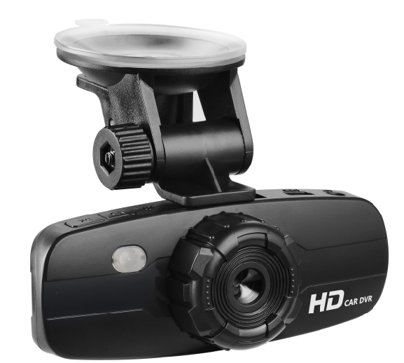

Photograph / Video Record / Audio Record

★ PRECAUTIONS
Please read the manual thoroughly before using.
Please keep the device away from hi-heat, high humidify or other extreme environments when store or use. This device has no built-in internal storage space, please purchase standard TF card before using. This device is a digital video recording platform, we're not responsible in case of data loss caused by man-made or body damage.
CONTENT
PRECAUTIONS ………………................................................................……………..... 1
CONTENT…………………………………...................................................…..... 2
INTRODUCTION …………………………….....................................................…………. 2
START-UP………………………...................................................................…………. 3
REC AND PLAYBACK …………………...........................................................…......... 4
CONNECTING TO COMPUTER ……………........................................................………….. 8
CONNECTING TO TV .................................................................................................…............ 8
SPECIFICATIONS …………………………..................................................................…........ 9

INTRODUCTION
Features
·HD A/V recording
·Motion detection recording
·Automatic circular recording
·Seamless transition of adjacent images
·Support AV signal output
·Dark auxiliary LED
·Support a variety of ceiling car snaps
Product overview
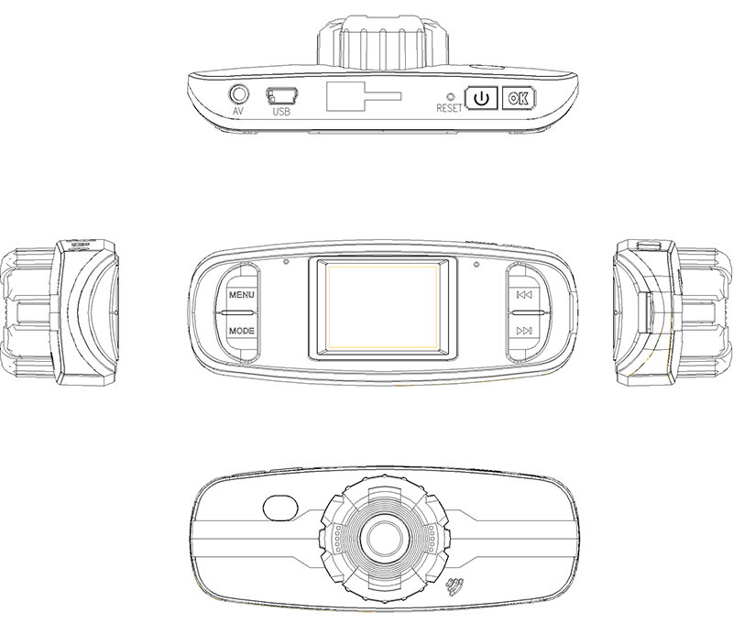
Parts introductions:
: Power on/off button.
OK: Confirm key, confirmation of a variety of state and the execution key for photograph / video recording / audio recording.
MODE: Mode switch key, toggle between photograph / video recording / audio recording / file playback .
MENU: Menu key, to pop-up the submenu.
◀ and ▶: Direction keys, it is used as left and right keys in the menu.
RESET: Reset button, locates beside the power button. When the device does not work properly, press it with sharp objects for forced shutdown.
AV: Audio and video output jack.
USB: USB interface, for data communications and external power connector.
TF card slot: TF card slot, TF memory card socket
Accessories
1. USB cable
2 Car snaps
3 Car Power
4 Instructions
5. AV Cable
6 Driver disk (optional)

STARTUP
Power on/off
1. Insert memory card before boot: put the device body face up, push the memory card horizontally into the memory card slot on the rear of the device until you hear a slight combination sound, which means the memory card is successfully installed.
Note: There is corresponding prompt if there is no card inserted or broken card inserted.
2. Boot:
Manual: press the power on/off button to turn on the device.
Auto: when it is connected to a working power adapter, the device will automatically turned on. If the device is loaded with a memory card, the device will start recording automatically as preset.
3. Shutdown:
Manual: in power on state, press and hold power on/off button to turn off the device.
Auto: to automatically shutdown the device, enable the Auto shutdown option in the settings, after the device continuously standby certain time, it will automatically power off.

Battery indication
When the device is not connected to power adapter, please pay attention to the battery indicator, stop using and charge the battery if low battery.
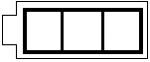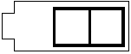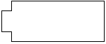
Full battery Sufficient battery Low battery Lower battery alarm

System settings

In power on status, press MENU key to pop-up menu, press MODE key to switch to System settings menu.
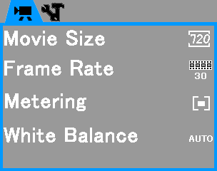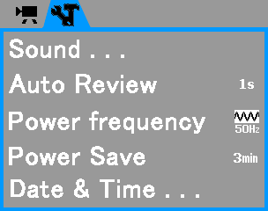
The system setup menu includes multiple parameter settings:
- Sound settings
To setup the sound of power on/off, shutter and volume
- Auto playback
To setup auto playback time
- Power frequency
Power frequency match, usually it is selected by default.
- Auto shutdown
To setup the wait time from standby or idle state to auto shutdown
- Date & Time
To setup the date and time for the device (The date and time will be restored if the battery is out of power caused by the device not in use for long time)
- Language settings
To setup the operating language
- Startup screen
To select the startup screen type
- LED
LED Switch option
- Version info
The firmware version information of the device
- Formatting
To format the memory card will delete all the data stored in the card, please be careful before operating.
- Restore factory settings
Restore default value

REC AND PLAYBACK
Below instructions is for memory card is inserted

Video recording
Manual recording
1. After turn on the device, stay in the video recording preview statue, it will display some general information, including current capture mode, preset size, remaining recording time, battery indicator., etc.
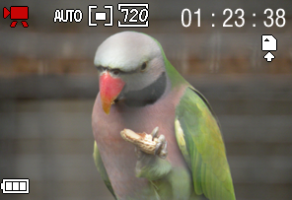
2. Press the OK key to start shooting in default mode.
3. Shoot menu settings. When you want to adjust the shooting parameters, you will need to setup the parameters accordingly.
Press MENU key to pop-up shoot menu to adjust movie size, single movie time, time watermark and other common parameters. Press MENU key to gradually exit after settings.
Note: After the auto circular recording is enabled, the device will keep recording accordingly. If the memory space is insufficient, it will automatically delete the oldest recorded files instead of manual eliminating. Please backup important records before paragraph to avoid being covered automatically.
4. LED shooting
In power off status, connect to the working power adapter, after the device is turned on automatically, the device will enter video recording state automatically, and the LED light will automatically light up.

Auto recording
This chapter will introduce photo shoot.
In power off status, connect to the working power adapter, after the device is turned on automatically, the device will enter video recording state automatically, disconnect manually will stop recording.
PHOTOGRAPH
This chapter will introduce photograph
- After the device is turned on, in video recording preview status, press MODE key to switch to photograph preview mode.
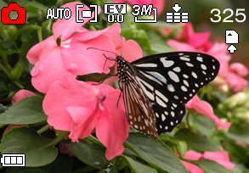
- Press OK key to take photo directly.
- Set photograph parameters. Press MENU key to pop-up menu to set photograph parameters. You can set resolution, quality, metering, white balance., etc.
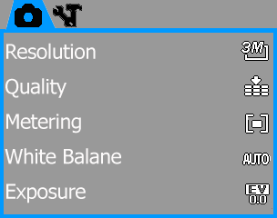
SOUND RECORDING
This chapter will introduct sound recording
- After the device is turned on, in standby status, press MODE key to switch to sound recording mode.
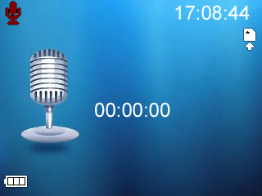
- Press OK key to start recording, and the digit appear on the screen will start count.
- Press OK key again to stop recording.

PLAYBACK
This chapter will introduce the playback of video, photo and sound record
★ Enter into playback mode
In standby mode, press MODE key to switch in turn, it can switch to the initial state of the last recorded file, then press left and right key to select desired file to play.
★ Video playback
1. Recognition of videos: thre is a icon in the lower left corner
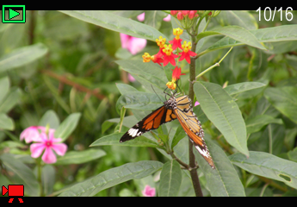
2. Playback: press OK key to play/pause.
3. Menu operation: in pause status, press MENU key to pop-up menu to lock or delete the current file.
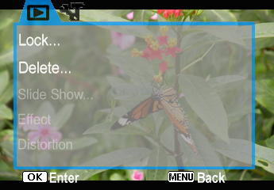
★ Photo browse
1. Recognition of photo: there is no icon in the lower left corner.
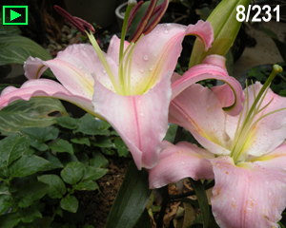
2. Menu operation: press MENU key to pop-up menu to lock or delete effect edit to the current file.
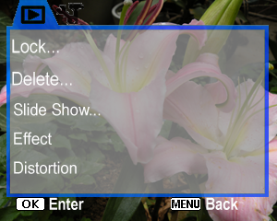
★ Recording playback
1. Recording playback: similar as sound recording, however, there is a playback icon at the upper left corner and there is a  icon at the lower left corner.

2. Sound playback: press OK key to play/pause, press MENU key to stop playback.
3. Menu opration: in pause status, press MENU key to pop-up menu to lock or delete the current file.
CONNECT TO COMPUTER
This chapter will introduce methods and steps to connect to computer
Two methods to connect to computer: mobile HDD mode and PC Camera mode. When there is no setting made, the connection method is the same: in optional status, use the supplied USB cable to connect to the computer and the USB interface of the device, the device will appear the option prompt of connection mode.
- Mobile HDD mode: to read and write the memory card of the device after connected.
Connection method: before connecting USB, enter USB menu settings to select "Mobile HDD" and then connect USB cable.
- PC Camera mode: use it as the camera of the current computer.
Connection method: before connecting USB, enter USB menu settings to select "Camera" and then connect USB cable.
Notes:
a. the computer will require installing coresponding software driver if it is the initial time to use PC Camera.
Steps: ⊙ Fetch the supplied CD and put it into the CD-ROM of the computer.
⊙ Open the drive and find the exe document and then install;
b: press MODE key to switch between mobile HDD and PC Camera mode.
CONNECT TO TV
Connect the device to TV with supplied AV cable via AV signal input source ( video /audio signal has a connector), set the TV to current signal input source status, the playback mode will switch to TV after the device is turned on.
SPECIFICATIONS
Dimensions | 109mm×41mm×33mm( L×W×H)
Weight | Approx. 97g
Display | 1.5inch color display screen (1.8inch optional)
USB interface | USB2.0
Built-in Li-battery | 0.5H continuous work after fully charged (for reference only)
Memory | Supported capacity: 512MB/1GB/2GB/4GB/8GB
REC | Format | WAV
CMOS camera | Resolution (pixel) | HD 30w pixel physical fixed focus
CMOS camera | Bit depth | 24bit
Recording | Format: AVI  Resolution:1280*720, 720*480, 640*480
Photo | Format: JPG  Resolution:3456*2592, 3648*2048, 2592*1944, 2048*1536, 1600*1200, 1024*768, 640*480
Temperature | 0~40℃
Menu language | English, Simplified Chinese, Traditional Chinese, Russian, Italian, Korean., etc.
Notice: specifications are subject to change without prior notice.

