D602 Manual

D602 is a pocket size oscilloscope. It built in Lithium battery.support user move to anywhere.
D602specification:
- Big TFT screen，3.2寸LCD,240*400 pixel.
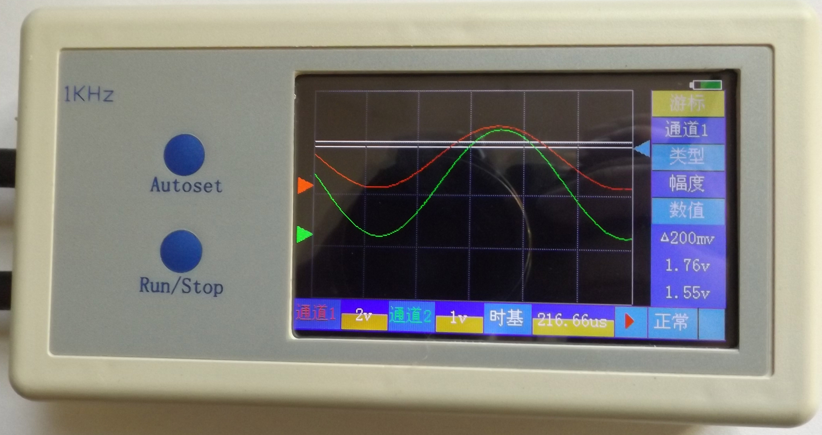
- bandwidth 200KHz,1MHz samplerate.
- double channel input,enable/disable channel。
- touch panel.
- smaller but multi function.
- 12 bit ADC.
- 1Khz square wave output
- Language: Chinese/English select on menu.
- Li Bettray in machine, can use 8 hours.
- DC9V outside power. Don’t use other power.
accesscory:
MCX probe 2
D602 1
DC9V 2000mA 1
Touch pen 1
11、weight：0.4kg
12、size：250*135*50mm

Meun Rect:
Click the rect area, switch different menu.

Waveform rectangle area
Menu Value Rect
Click it,the value will change,click angain,untill appear you want value.

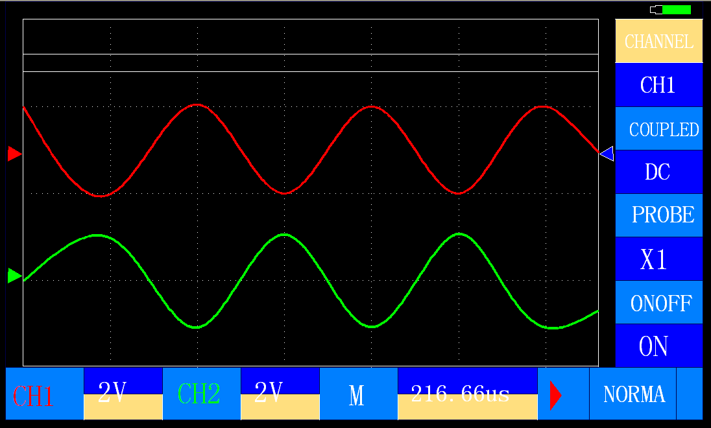

Channel Zero triangle
Trigger triangle use for adjust Trigger voltage

Menu Title Rect
Prompt function for rect value

Click Yellow area Adjust Down voltage tap position
As voltage adjust,but this item use for pluse width.
Voltage adjust:Click blue area Adjust up voltage tap position
Normal//Fine Button

RUN/STOP

Turn on machine
Before turn on machine,mack sure power input is DC9V,if all ready then press power switch for turn on machine.
matters need attent
The probe have a switch on probe head，can switch X1,X10,when on X1,input resistor is 1M ohm,if X10, input resistor is 10M ohm.,x1 input cannot over 10V, X10 input cannot over100V。
X1:input resistor 1M ohm,if input signal smaller than 10V,switch to X1
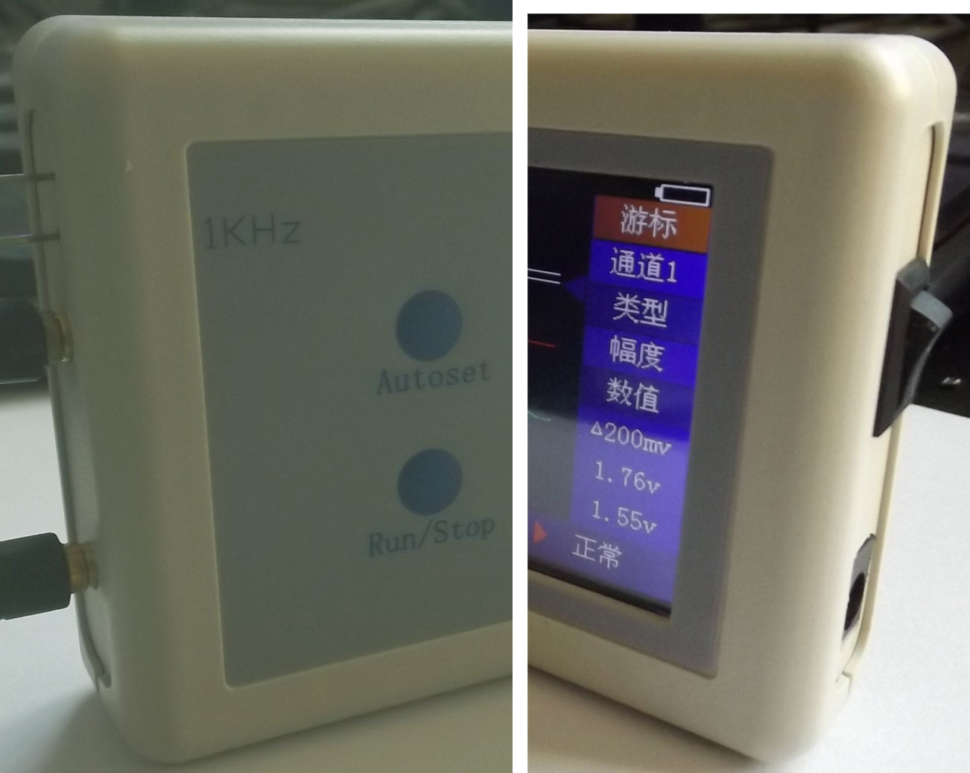
DC9V in
Power sw
1KHz+
1KHz-
Ch1 MCX
Ch2MCX

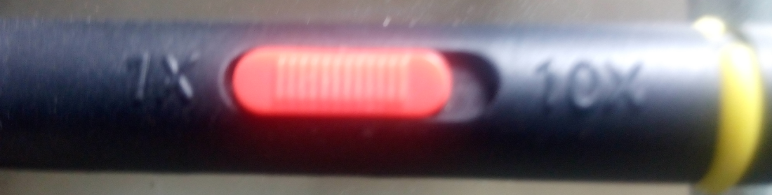

X1:input resistor 10M ohm

Channel option setting:
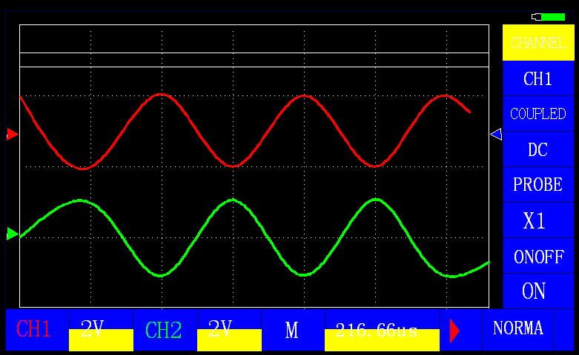
D602 have two channel,so channel can select ch1/ch2,click the ch1 menu value rect area,then it will change value.
Coupled:the option have two item:DC and AC,if you want display sig have not dc sig,you can select AC mode,in this mode,only have dc sig is value zero.
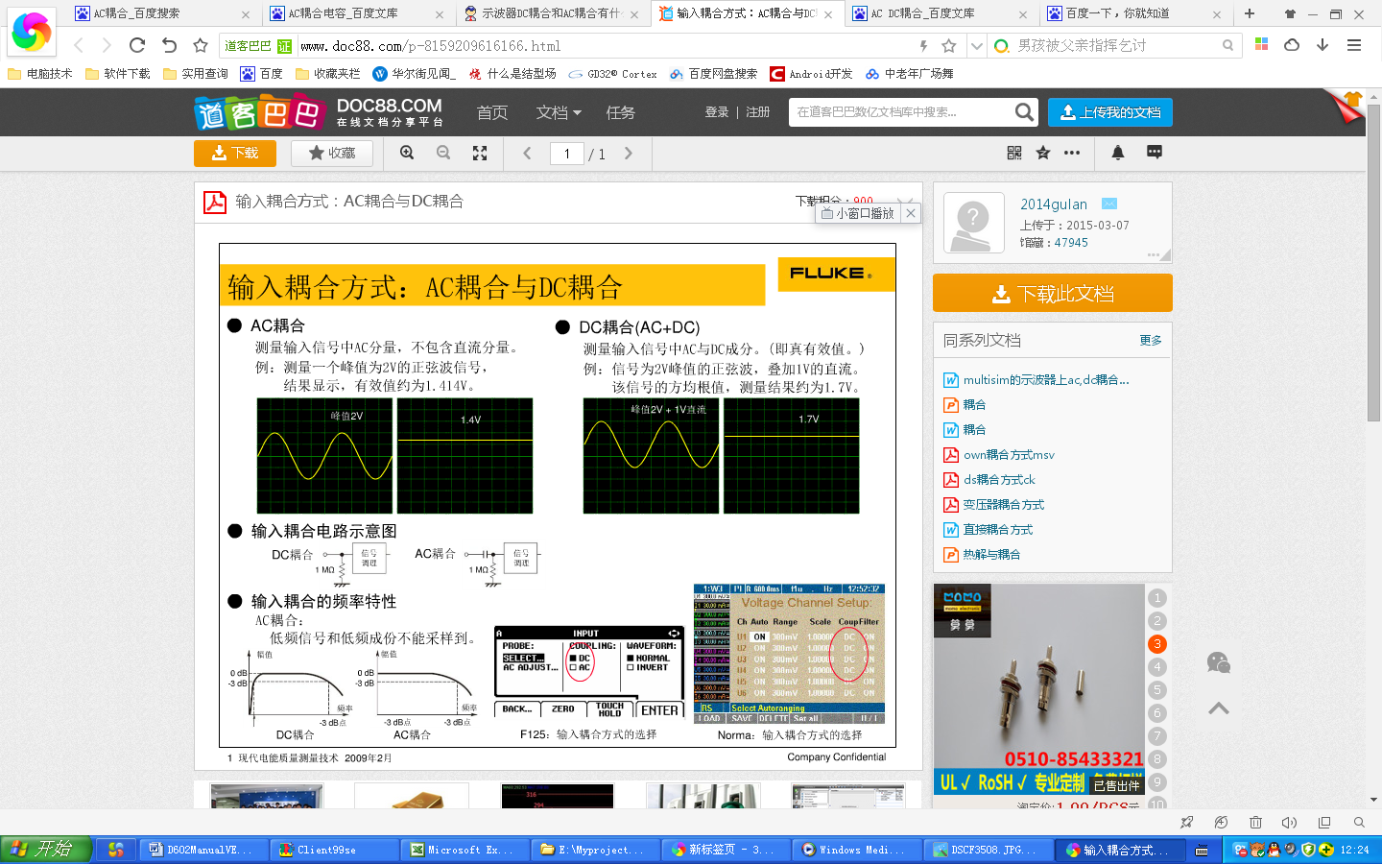

(DC coupled)

Example,the input sig is 2V PPK sine waveform add 1V DC,
If you set coupled is DC,then see the wave will be like (Dc couple) image display.
If you set coupled is AC,Display is only have 2V
PPK sine wave.
(AC coupled)

Probe:accessories have two Probe,on the probe have a switch,the switch can turn probe impedance to X1(1M) or X10(10M).if you test sig is smaller than 10V,you maybe turn switch to X1,because in X1 ,input sig attenation is smallest,if you select X10,you will see transformation sig.
If you test Bigger than 15V sig,you need turn attenation switch to X10,if you not turn to X10,the machine maybe damage.because the input is too bigeer in X1.
Turn on or turn off the channel display,if you need see a channel waveform display,you can turn off other waveform. channel

Trigger option setting:
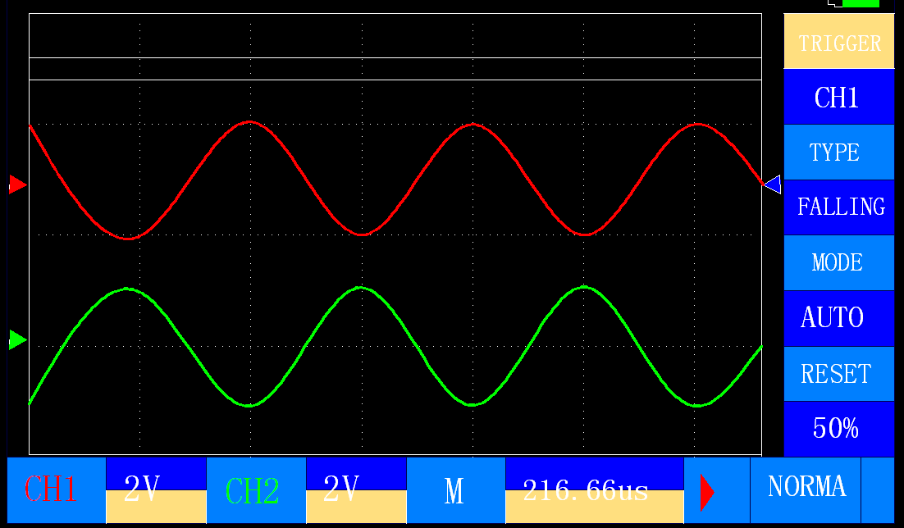
Oscilloscope adopt two way to sampling input sig,one is input voltage bigger than the set(Rising set)or smaller than the set(falling set),then oscilloscope will start sampling input signal. Another is,oscilloscope timer to sampling signal.if you set trigger mode in Auto,if there is haven’t voltage trigger.in normal mode,the timer trigger is disable.if have not a voltage trigger,the display waveform will not refresh,untill a voltage trigger occur.
Rest 50%,will move the trigger icon to screen mid.the trigger icon is right side on waveform display rectangle.you can move it to appropriate site.

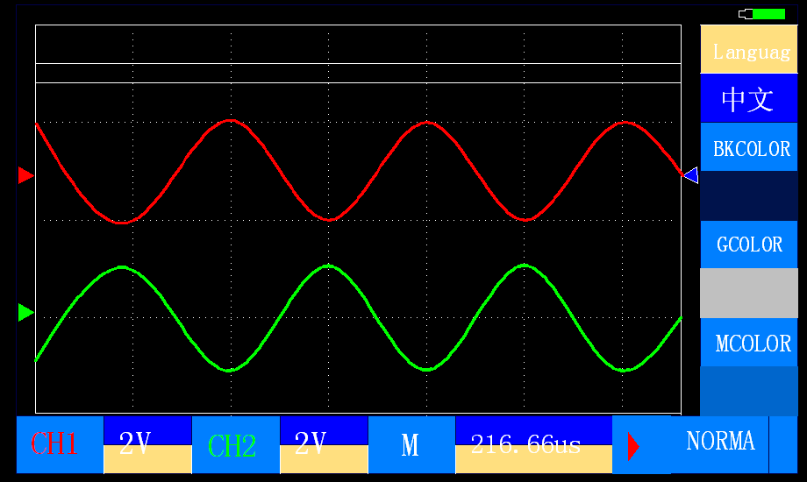
Language option setting:
D602 have two language support,English and 中文.
You can click the value rect to switch.
Background color,grid color,and menu color,you can select as you like;

Cursor Option setting:
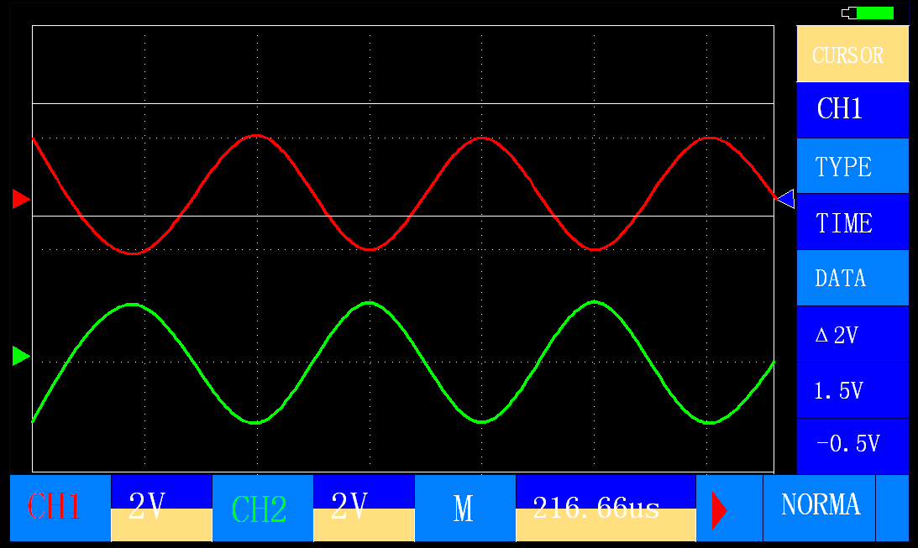
Cursor use to manual measure signal’s pluse width or voltage.
Channel can select ch1 or ch2,if you want know ch1’s pluse width or voltage,you must select ch1.
Type have two item,Scop and time,in scope,two white line is horzontal,then they use for measure voltage. In time type,two line is vertical,then they use for measure pluse width.
Following is data column.first data have a “Δ”,this data is cursor line’s subvalue.
Second and thrid relevant with cursor line whereon;

Measure Option setting:
Measure channel can select ch1 or ch2.click ch1 will switch to ch2.
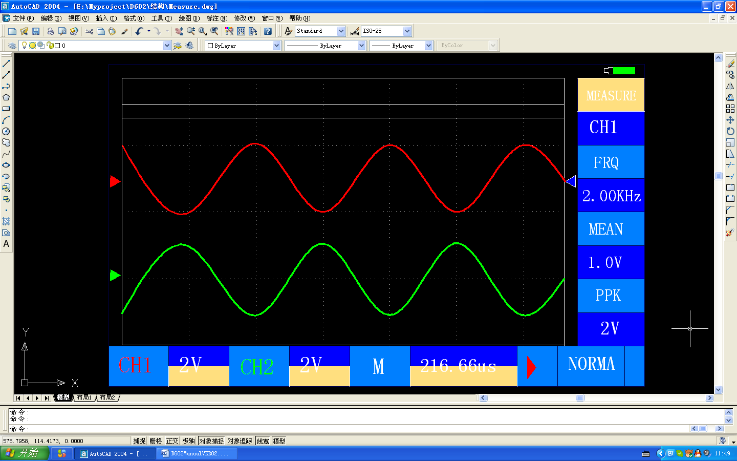
Click relevant display value,then will switch measure type.the measure type have four item:
PPK,MEAN,FRQ,COUNTER.
PPK:peak to peak value.(top sub buttom )’s subvalue.
MEAN: average the signal value.
FRQ:frquency,measure channel input signal’s frquency;

Channel color option setting:
User can change channel and text ,text background’s color.

Adjust up Voltage
Adjust up Voltage
Adjust up Time
RUN
Refresh Screen

Adjust down Voltage
Adjust down Voltage
Adjust down Time
Normal/Fine

adjust voltage or time tap position:
The voltage tap and time tap have two color rectangle,click up rectangle,will add relevant tap. Click down rectangle will sub relevant tap position.
If probe attenation switch in X1:the voltage tap have：50mv,100mv,200mv,500mv,1V,2V,5V;
If probe attenation in X10:the voltage tap have :1V,2V,5V,10V,20V,50V,100V.

Click Normal button to fine,regualation the time tap,you will find the tap’s step smaller then normal mode.
Refresh screen:if screen have some point,or littery,press after normal button ‘s bank button.screen will refresh to pure.

Run/Stop: press red triangle button.oscillscope will switch run to stop,or stop to run. Some function is on oscillscope panel’s “run/stop” button.

Autoset
Press down Autoset button,System can auto set scope and pluse width to proper value。
Touch panel
Specifically action
Scope adjust:in running，press touch pannel move to right or left,can switch scope value.
Waveform moving:in stoped,press touch pannel move to right or left，can move waveform,if sleek but not undog，waveform will coutiune move。
Waveform zoomin\zoomout:in stoped,sleek screen up or down,can zoomin/zoomout waveform..

About us
YIRU is a factory,have software ,APP,
Electrocircuit develop and manufacture.
contact us :
Email: hsqgis@qq.com

YIRU

