## How do I get SBUS on this?

1.Connect this port

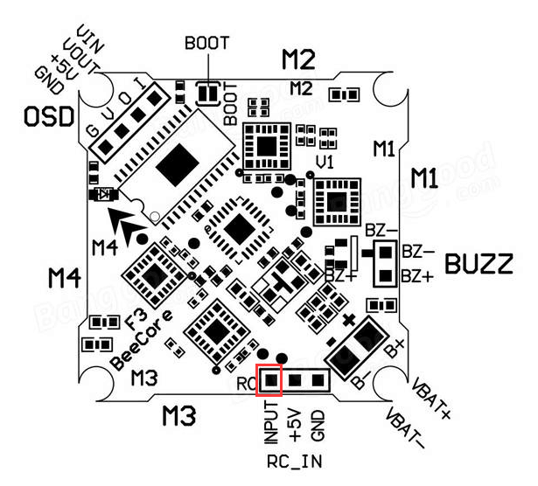

1. Receiver setting

